Checklist for
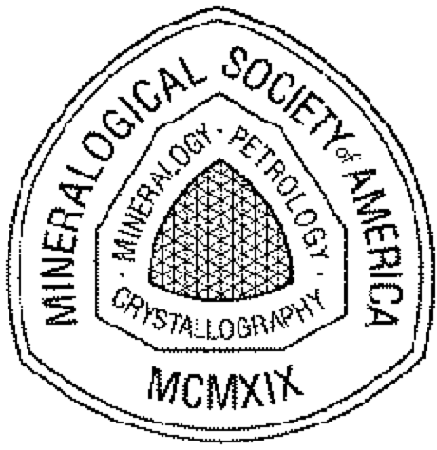
Mineralogical Society of America
Award or Medal Nominations

(Please indicate one):

[ ] Roebling Medal
[ ] Distinguished Public Service Medal
[ ] Dana Medal
[ ] Mineralogical Society of America Award Date: ____________________________

****************************************

Nominee:
Address:
Address:
phone:
e-mail:

Date of birth or date of most advanced degree
for MSA Award nominess only: ______________

Sponsor:
Address:
Address:
phone:
e-mail:

(There needs to be at least 3 but no more than 5 co-sponsors of the nomination)

Co-Sponsor 1:
Co-Sponsor 2:
Co-Sponsor 3:
Co-Sponsor 4:
Co-Sponsor 5:

****************************************

Required Information
(1) this cover page
(2) a cover letter from the nominator outlining the candidate's qualifications in light of the criteria for the award.
(3) supporting letters from at least three (3) but no more than five (5) other individuals are required and should focus on how the candidate meets the criteria of the award.
(4) curriculum vitae and a bibliography of published works exclusive of abstracts, book reviews, and papers that have not yet been accepted for publication.
(5) any supplementary materials that bear on the award criteria.

****************************************

The committee asks that the nominator compile into a single electronic file the nomination, all letters of support, and supplementary materials before submitting the nomination package to the Committee Chair. This single electronic file makes it easier and less expensive for the committee members, who are increasingly international, to do their work.

The nomination package must be submitted to the chair of the respective Committee for the award by June 1. You can obtain their contact information by visiting the appropriate web page for:

Roebling Medal
Distinguished Public Service Medal
Dana Medal
Mineralogical Society of America Award

or, you can send the nomination package to:

MSA Business Office
3635 Concorde Pkwy Ste 500
Chantilly VA 20151-1125 • USA
Tel: +1 (703) 652-9950
Fax: +1 (703) 652-9951
e-mail: business@minsocam.org
Internet: www.minsocam.org

Nominations can be carried over to following years if the nomination package is updated by the sponsor. Any nomination not renewed after 2 years will be not considered further.

(revised 12/13/2005)
Copyright (c) 1997 - 2006 Mineralogical Society of America. All rights reserved

