Supporting Online Material (Revision 1 with correction of “Chebyshev” )

Materials and methods

Natrolite used in this study is from San Benito County, California, USA, with a composition Na_{1.84(2)}Al_{1.94(2)}Si_{3.10(2)}O₁₀ • 2.0(1)H₂O (Z =8), an average of electron microprobe analyses (EPMA) of crystals in several thin sections. The sample was crushed into a fine powder using a Retsch Micro-Rapid mill with agate mortar and pestle and was studied using an Anton-Paar TTK-450 heating stage on a Bruker D8 diffractometer (Cu Kα radiation) equipped with a Vantec position-sensitive detector. The diffractometer was calibrated using NIST SRM 660a LaB₆. Powder X-ray diffraction (XRD) data were collected in-situ between 23ºC and 400ºC in air under controlled conditions at 0% to 87% RH (measured at ~23ºC), and in vacuum ( ~0.15 mbar) with the same heating rate, measuring from 12º to 120º 2θ and counting for 0.66 s at each 0.017º 2θ step. The sample was equilibrated at least 60 mins prior to each data collection. To ensure completion of dehydration and attainment of a stable diffraction pattern, longer equilibration times were used from 1 hr to 2 dy. Two different mounting methods were used to assess the reaction kinetics during natrolite dehydration reaction, a cavity mount (0.2 mm depth) and a thin-layer slurry mount. The much larger sample mass (~16 mg) and thicker sample used in a cavity mount increases the opportunity of build-up of P_{H2O} in intercrystallite pore spaces, which inhibits the temperature at which the phase transition began and results in longer times required for completion of dehydration. Conversely, a thin-layer slurry mount minimizes build-up of P_{H2O} in intercrystallite pore spaces, thereby providing a more accurate picture of the phase transition behavior. However, determination of crystal structure from powder XRD data requires an effectively infinitely thick sample to obtain accurate intensity information. Hence, our determinations of the α1- and α2-metanatrolite structures and Rietveld refinements of natrolite, α1-, and α2-metanatrolite phases were performed using XRD patterns measured with cavity mounts under vacuum condition (i.e., P_{H2O} of 2.56(2) μbar, controlled at 59.6(3)% RH, 23.3°C, and ~0.15 mbar total pressure).

Unit-cell parameters of natrolite at 23ºC (a = 18.2915(3) Å, b = 18.6324(3) Å, c = 6.5856(1) Å, V = 2244.5(1) Å³) were determined by Rietveld refinement in space group Fdd2 in accord with Peacor (1973). Tetrahedral Al and Si atoms were assumed to be fully ordered in accord with Neuhoff et al. (2002) who reported nearly complete ordering in material from the same locality by ²⁹Si MAS NMR measurements. The starting structure of α1-metanatrolite was adopted from Baur and Joswig’s model (1996) and was first optimized using rigid-body and distance least-squares (DLS) refinements in space group F112. Soft constraints were applied to the Si-O, Al-O, and O-O bond distances using 1.61±0.02 Å, 1.74±0.02 Å, 2.65±0.04 Å and 2.85±0.04 Å for the Si-O, Al-O, O-O of Si-tetrahedra, and O-O of Al-tetrahedra, respectively (Alberti and Gottardi 1988). The starting structure for α2-metanatrolite was determined using those reflections that could not be indexed by α1-metanatrolite, in space group Fdd2 (the same as natrolite). Using this space group and approximate unit-cell parameters, rigid-body and DLS refinements were conducted for α2-metanatrolite with the same bond-distance constraints as used for α1-metanatrolite. To index the measured pattern, we use McMaille v.3.04 (Le Bail 2002) and TOPAS-Academic v.4 (© Bruker AXS, Karlsruhe, Germany) to determine possible unit-cell parameters and space groups. The GSAS software package (Larson and Dreele 2000) was used for DLS refinements and for subsequent Rietveld refinements with XRD data collected at different temperatures.

Rietveld refinements for metanatrolite were carried out assuming the distribution of Al and Si to be fully ordered, in accord with refinement results from natrolite at 23ºC, using data from 12º-120º 2θ. An eight-term shifted Chebyshev background function and the pseudo-Voigt profile function were applied. Unit-cell parameters, scale factors, specimen displacement, and profile parameters were initially refined, with the positions of all atoms fixed. Sources of peak broadening as a function of temperature through the phase transition were analyzed by interpreting the different Lorentzian coefficients refined in GSAS, considering only microstrain broadening, because the analyses suggest that anisotropic microstrain makes a considerable contribution to the observed XRD peak breadths, with much less contribution coming from finite crystallite size. The contributions of anisotropic microstrain were constrained to be equal for both dehydrated phases and were refined together throughout the refinements. Preferred orientation was modeled using a spherical harmonics correction, and the refined texture index was between 1.13 and 1.19, indicating minor preferential orientation of the powder sample consistent with the fibrous morphology of natrolite.

After initial refinements, difference-Fourier maps were calculated to locate the Na⁺ ions. Isotropic displacement parameters (U_{iso}) were refined subsequently for all atoms of the tetrahedral framework and the extraframework Na⁺ ions, and the displacement factors were constrained to be equal for all atoms of the same type. Final atomic positions were refined with soft distance constraints for Si-O, Al-O, and a variety of O-O bond distances using the same distance constraints as used in DLS refinement, weighted so that they made up 6% of the total Minimization Function in all refinements [Minimization Function, M = Σ W_{i}(y_{o} – y_{i})²]. Refinement summaries for selected temperatures are given in Table 1. Figure 1 depicts a selected 2θ range from Rietveld refinements using XRD patterns measured at 23ºC, 300ºC, and 400ºC on dehydration.

Our crystal structure analyses have shown that natrolite dehydrated at 400ºC in vacuum is still a mixture of two anhydrous phases, α1- and α2-metanatrolite. Although the weight percentage of α2-metanatrolite slightly decreased from 325ºC to 400ºC, α2-metanatrolite does not completely transform to α1-metanatrolite, even after remaining at 400ºC for up to two days. In addition, Rietveld refinements with XRD data measured at 400ºC showed that the calculated diffraction patterns, incorporating both α1- and α2-metanatrolite, did not match several small peaks in the observed patterns, notably one at lower angle than the lowest-angle natrolite peaks (Fig. 1C); the first small peak at ~13.6º 2θ). The presence of a longer-spacing reflection in the dehydrated structure suggests the possibility of a superstructure that formed during dehydration. Although α1- and α2-metanatrolite have distinct structures in terms of unit-cell parameters and space groups, their tetrahedral framework topologies are still quite similar. We suggest that a stack of α1- and α2-metanatrolite blocks along the c axis may be a possible way of forming a superstructure. The superstructure may arise because the twisted chains along the c axis are similar in both α1- and α2-metanatrolite, thereby giving rise to the similar c unit-cell parameters. The a and b unit-cell parameters are significantly different, due to the different degrees of chain rotation around the O2 hinges, but the c unit-cell parameters remain similar during dehydration. Moreover, the anisotropic strain effects determined by Rietveld refinements indicate more strain (%) parallel to the c axis. The greatest observed microstrain was 0.57% at 400ºC parallel to the c axis (i.e., the possible coherent domain boundaries between two anhydrous phases are most likely normal to [001]). Much smaller, predominantly isotropic, microstrain was observed before natrolite underwent a phase transition. Consequently, the superstructure may consist of stacked α1- and α2-metanatrolite blocks along the c axis (similar to mixed-layer illite/smectite).
Table 1. Rietveld refinement summary (during dehydration, esd’s in parentheses).
Temperature (ºC)23250275300325400Natrolite (Wt%)10010010057.9(1)00a (Å)18.2915(3)18.2563(3)18.2434(3)18.2167(4)----b (Å)18.6324(3)18.6226(3)18.6179(3)18.6028(4)----c (Å)6.5856(1)6.5928(1)6.5987(1)6.6031(2)----V (Å³)2244.5(1)2241.4(1)2241.3(1)2237.7(1)----water occupancy (nat)1.00(1)0.98(1)0.93(1)0.84(1)----strain ⊥ to c (%) (nat)0.190(2)0.197(2)0.188(3)0.189(3)----strain // to c (%) (nat)0.190(2)0.197(2)0.188(3)0.186(2)----α1-metanatrolite (Wt%)00025.9(3)61.5(2)67.8(1)a (Å)------16.158(2)16.157(1)16.167(1)b (Å)------16.895(1)16.898(1)16.938(1)c (Å)------6.425(1)6.4335(5)6.4380(4)γ (º)------89.680(7)89.674(2)89.680(2)V (Å³)------1753.9(4)1756.5(2)1764.0(2)α2-metanatrolite (Wt%)00016.2(2)38.5(2)32.2(2)a (Å)------17.587(1)17.582(1)17.574(1)b (Å)------18.169(1)18.162(1)18.161(1)c (Å)------6.366(1)6.3635(4)6.3674(3)V (Å³)------2034.3(2)2032.0(2)2032.3(2)water occupancy (α1, α2)------0.000.000.00strain ⊥ to c (%) (α1, α2)------0.39(1)0.34(5)0.39(1)strain // to c (%) (α1, α2)------0.42(3)0.55(2)0.57(2)displacement (mm)0.193(1)0.212(1)0.252(1)0.317(1)0.326(1)0.339(1)R_{wp}*0.06440.06210.07200.06280.05840.0559R_{p}†0.04550.04340.05070.04410.04100.0416Reduced χ²‡21.4020.0325.9420.6218.817.03# of observations 520852085208529252925264# of reflections (nat)679679678688----# of reflections (α1)------108012361260# of reflections (α2)------602652652texture index (nat) §1.141.131.151.15----texture index (α1) §------1.181.151.19texture index (α2) §------1.181.161.18*
†
‡ Reduced
Note: I_{o} and I_{c} refer to observed and calculated intensities at a given 2θ step.
Note: the high values of reduced χ² result primarily from the soft constraints on bond distances.
§The texture index was determined from the spherical harmonics coefficients refined in GSAS.
For random texture, the index is 1, and the index is >1 for fibrous materials.

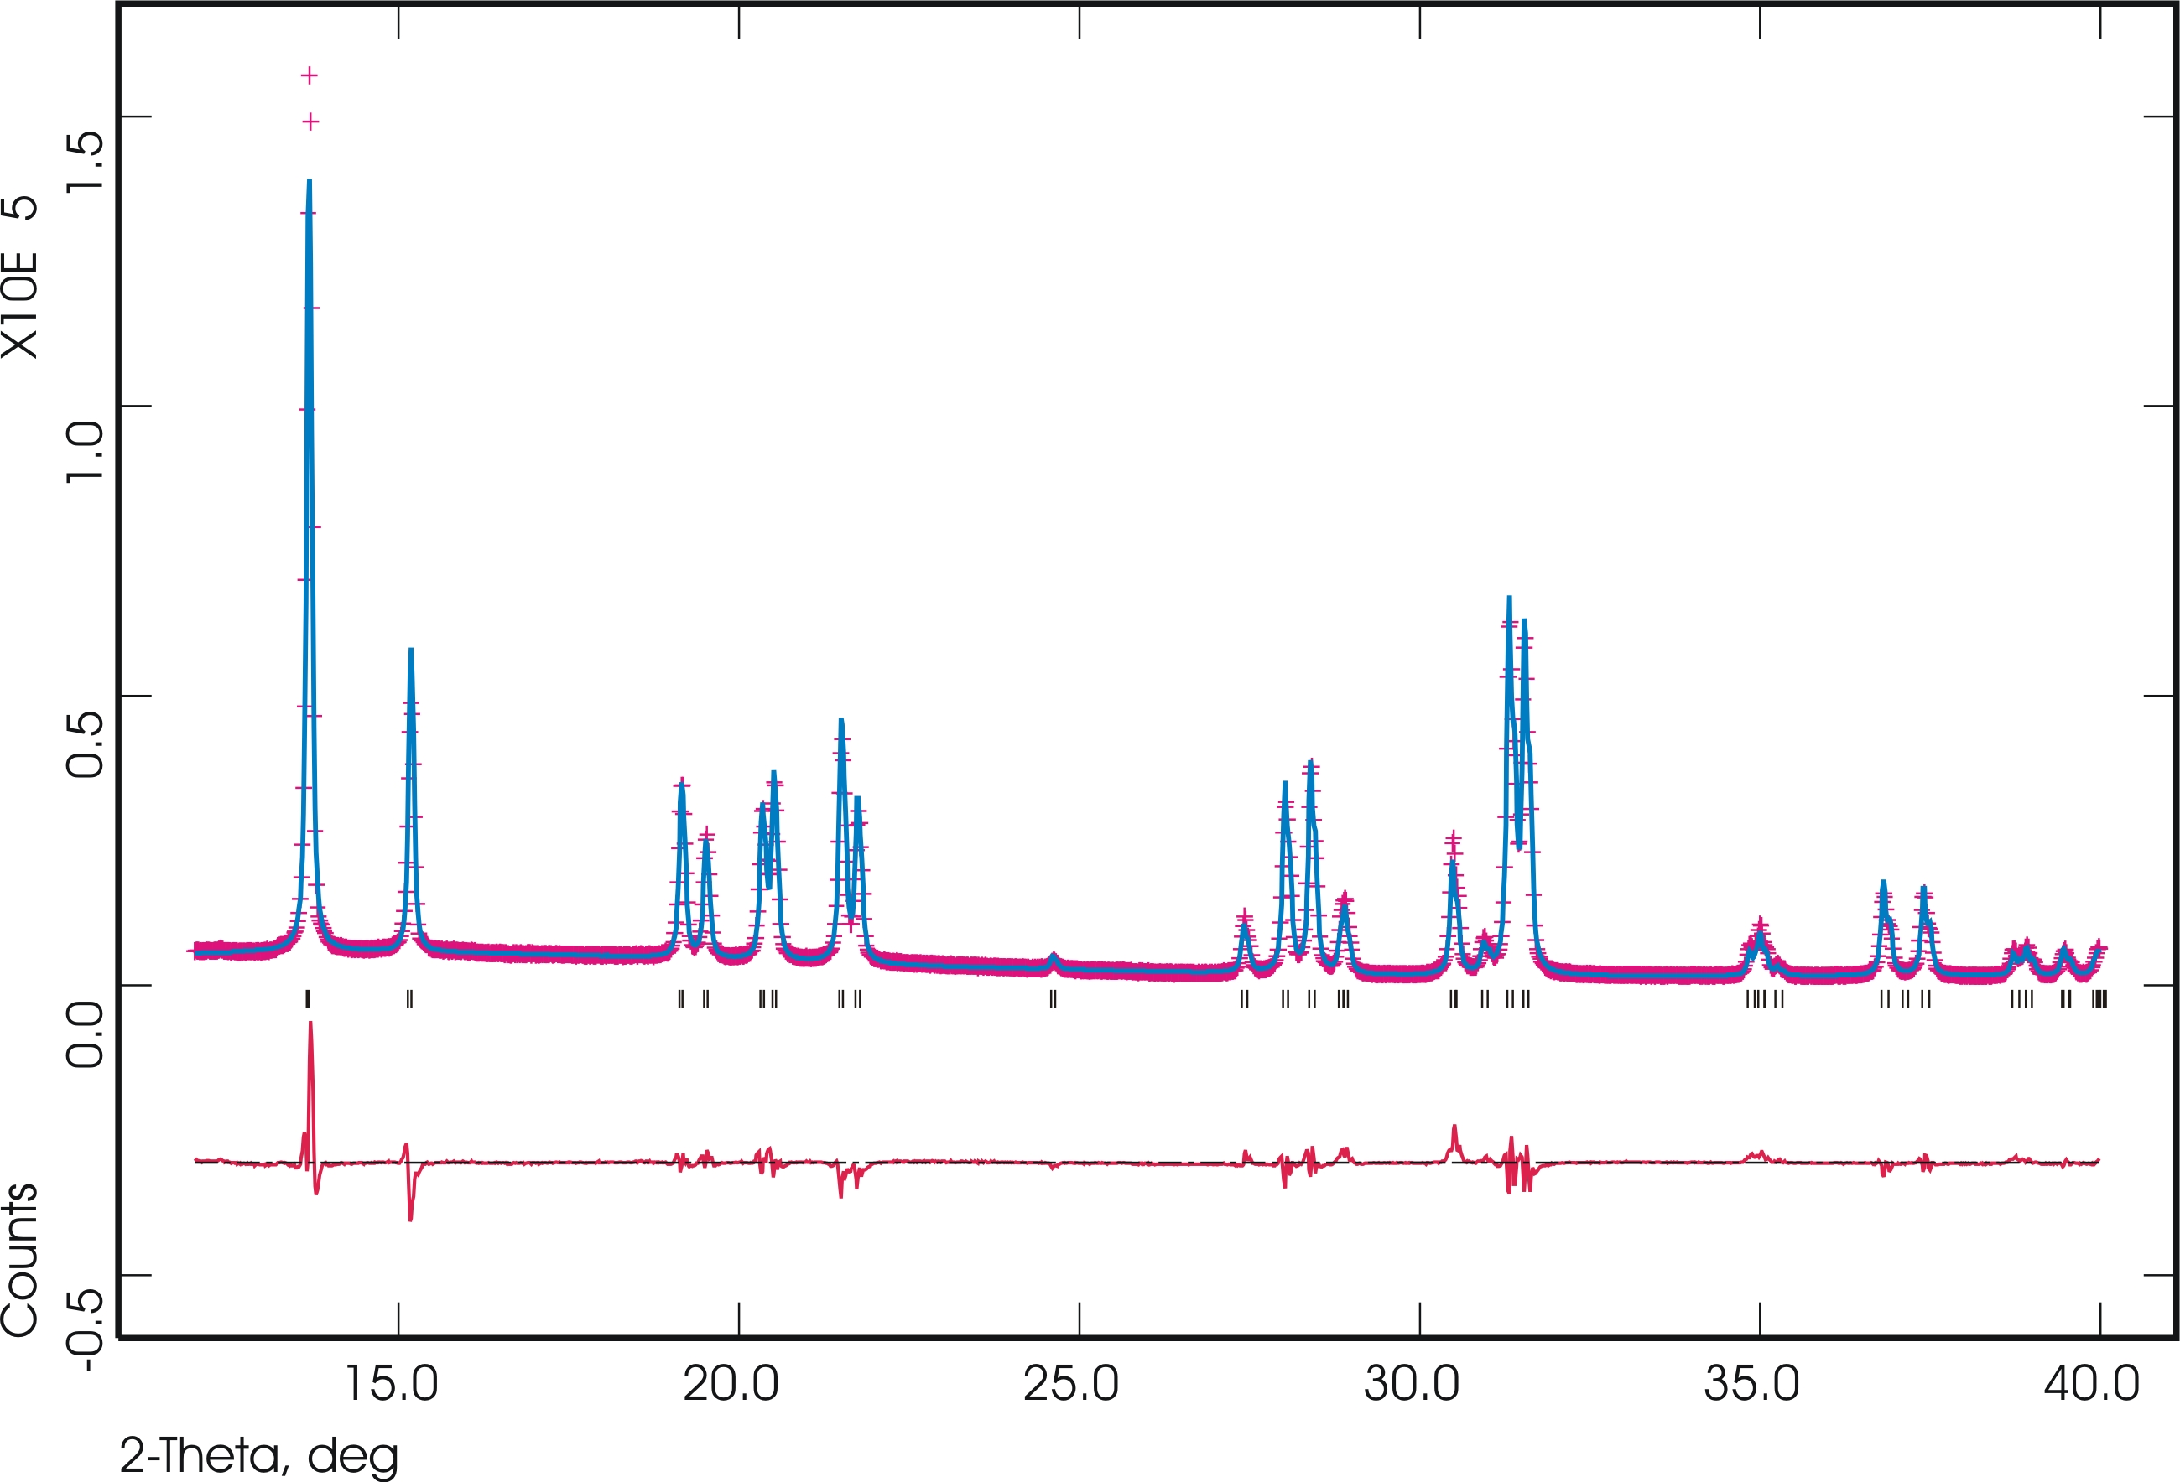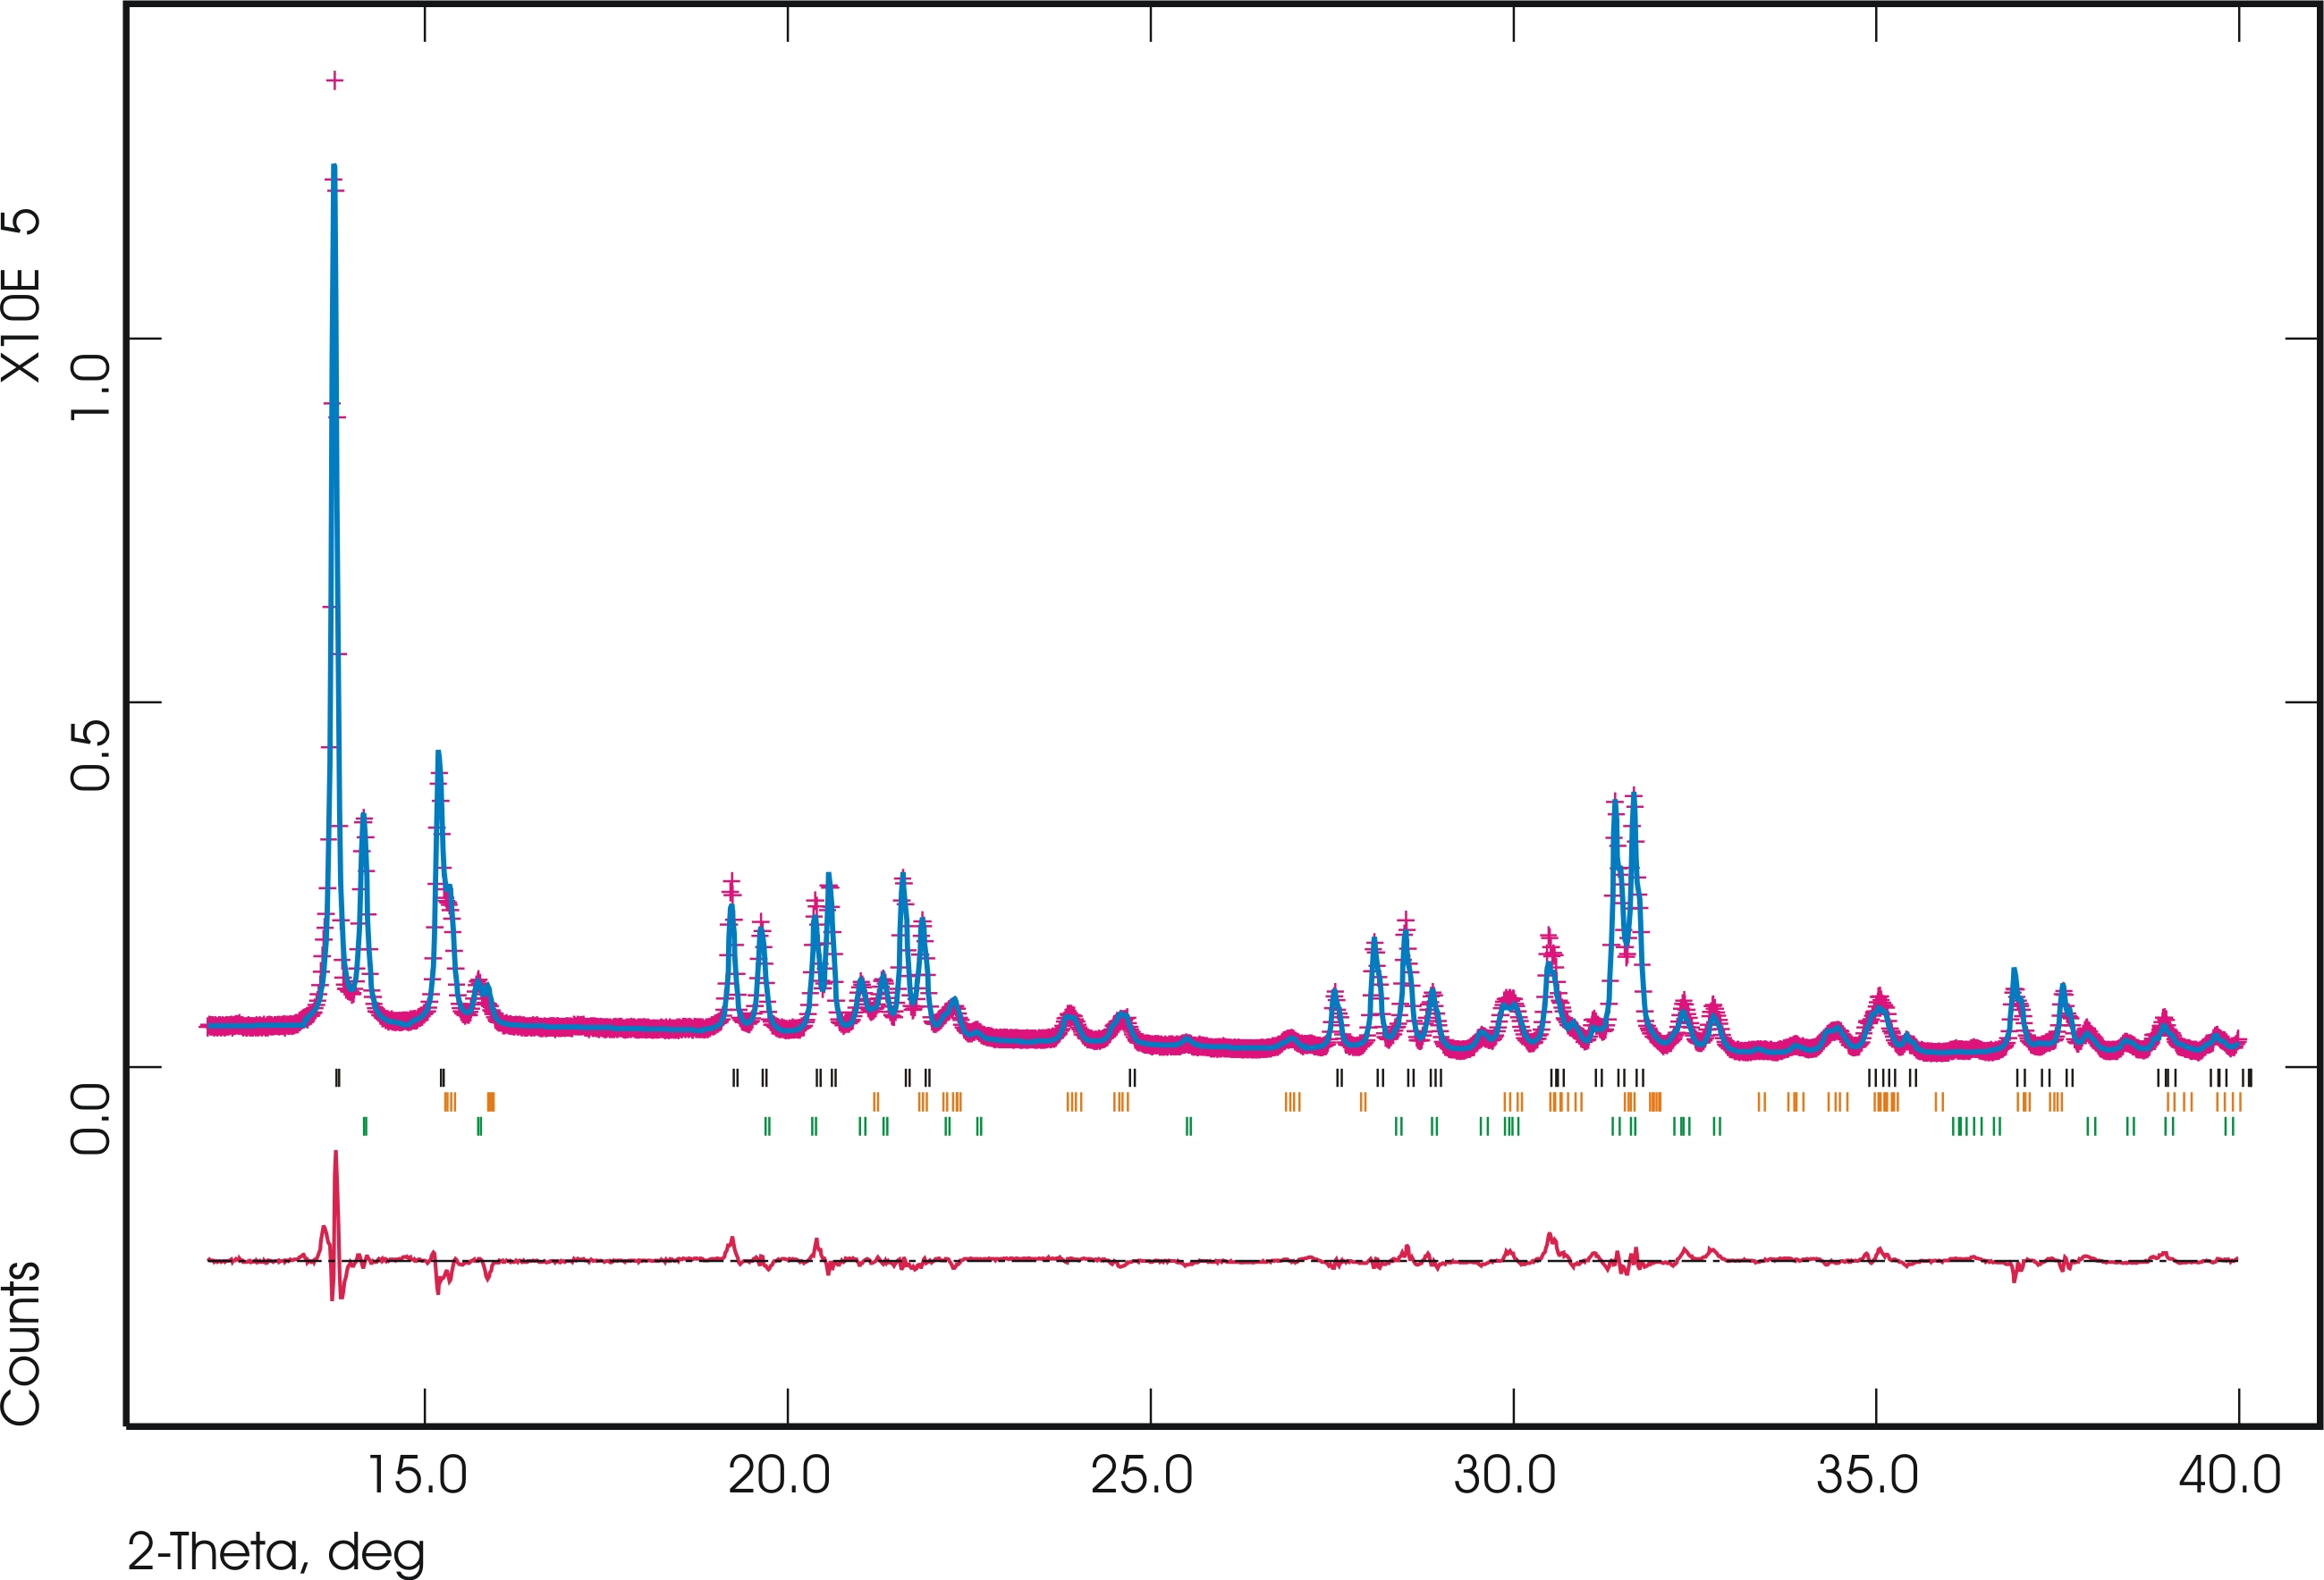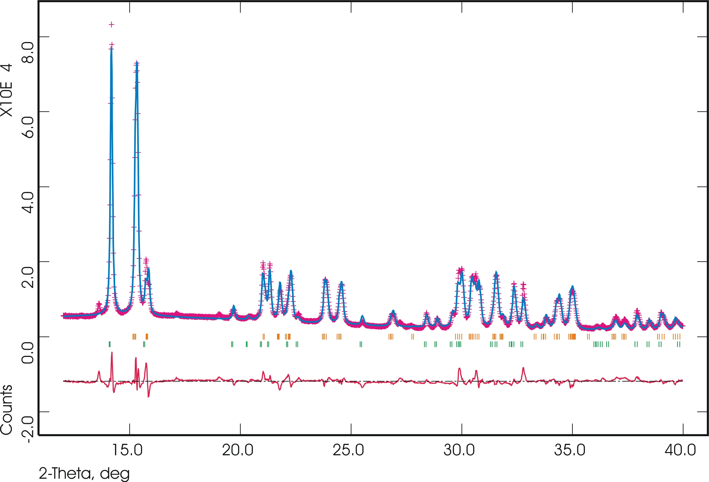
(B)
(A)
Figure 1. Powder X-ray diffraction data for natrolite (A) and its two dehydrated phases (B-C) collected at 23ºC, 300ºC, and 400ºC during dehydration (pink cross) together with the calculated (blue line) and difference plot (red line) from Rietveld refinements. Short vertical lines mark the positions of possible Bragg reflections (Kα1 and Kα2).
(C)
23ºC
- Natrolite 100%
300ºC
- Natrolite 57.9(1)%
- α1-metanatrolite 25.9(3)%
- α2-metanatrolite 16.2(2)%
400ºC
- α1-metanatrolite 67.8(1)%
- α2-metanatrolite 32.2(2)%
References cited
Alberti, A. and Gottardi, G. (1988) The determination of the Al-content in the tetrahedral of framework silicates. Zeitschrift für Kristallographie, 184, 49-61.
Baur, W.H. and Joswig, W. (1996) The phase of natrolite occurring during dehydration and rehydration studied by single crystal X-ray diffraction methods between room temperature and 923 K. Neues Jahrbuch für Mineralogie: Monatshefte, H4, 171-187.
Larson, A.C. and von Dreele, R.B. (2000) General Structure Analysis System (GSAS). Los Alamos National Laboratory Report, 86-748.
Le Bail, A. (2002) http://www.cristal.org/McMaille/
Neuhoff, P.S., Kroeker, S., Du, L.-S., Fridriksson, T., and Stebbins, J.F. (2002) Order/disorder in natrolite group zeolites: A ²⁹Si and ²⁷Al MAS NMR study. American Mineralogist, 87, 1307-1320.
Peacor, D.R. (1973) High-temperature, single-crystal x-ray study of natrolite. American Mineralogist, 58, 676-680.

