Special for Students of Geology, Mineralogy, Materials Science, Crystallography, Geochemistry, or Petrology
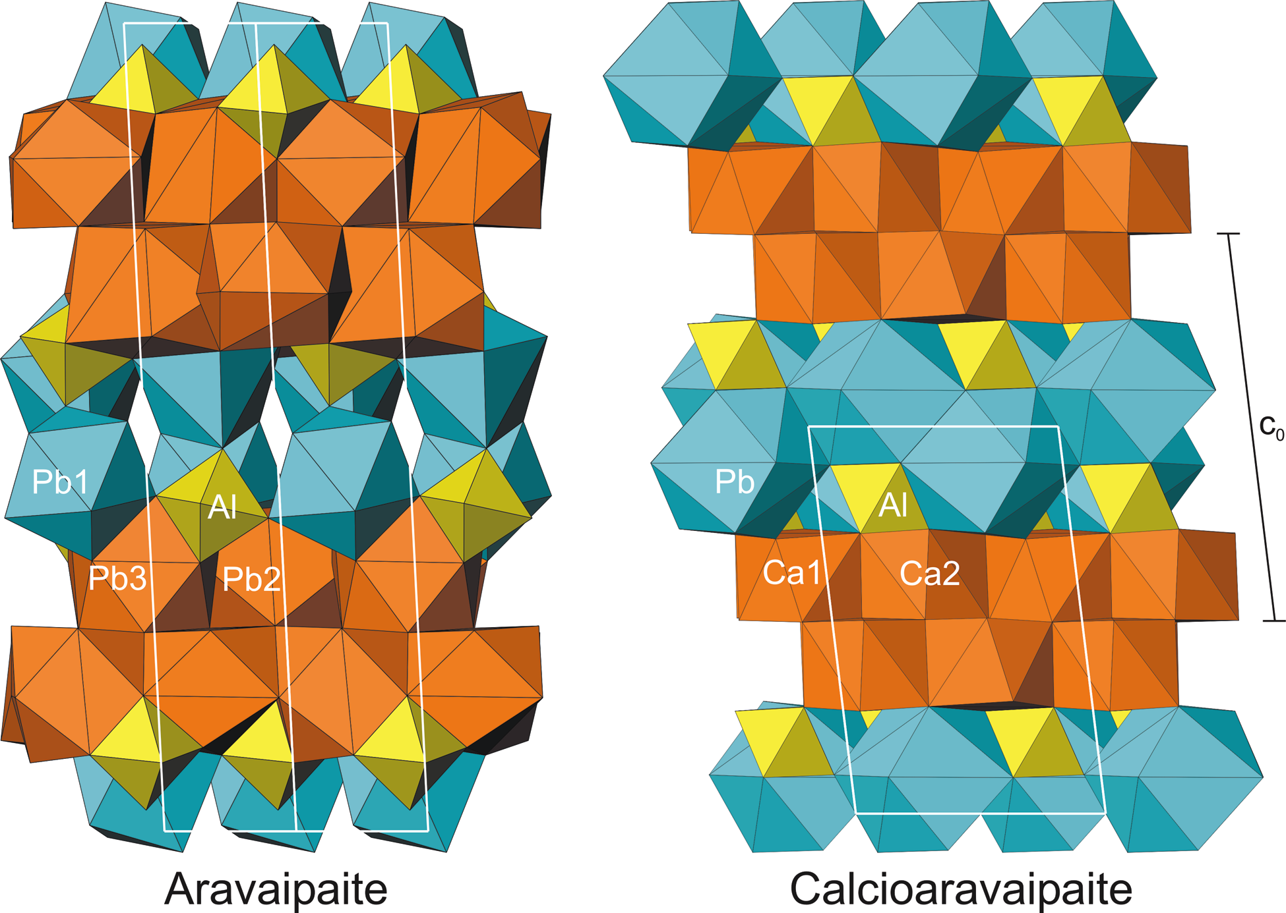

Join the
Structure of aravaipaite (Kampf et al. 2003).

Mineralogical Society of America

Dues are only $5 a year!

Receive the American Mineralogist at the low rate of
$10 Online or Hardcopy $35/year (8 issues)

Major discounts (25%) on
Reviews of Mineralogy and Geochemistry
(52 published so far, 3-4 every year on key topics)

Recent titles include:
Stable Isotope Geochemistry (662 pp) $32→$24
Micas: Crystal Chemistry and Metamorphic Petrology (499 pp) $32 → $24
Phosphates – Geochemical, Geobiological, and Materials Importance (742 pp) $40→ $30
Nanoparticles and the Environment (349 pp) $28 → $21
Planetary Materials (1039 pp) $40 → $30

Discounts on MSA short courses and Goldschmidt conferences
Discounted registration at GSA and AGU meetings
Grants for student research in crystallography, mineralogy, and petrology
Quarterly newsletter The Lattice
All figures are from American Mineralogist v. 88.

Check out MSA at www.minsocam.org and download a membership application
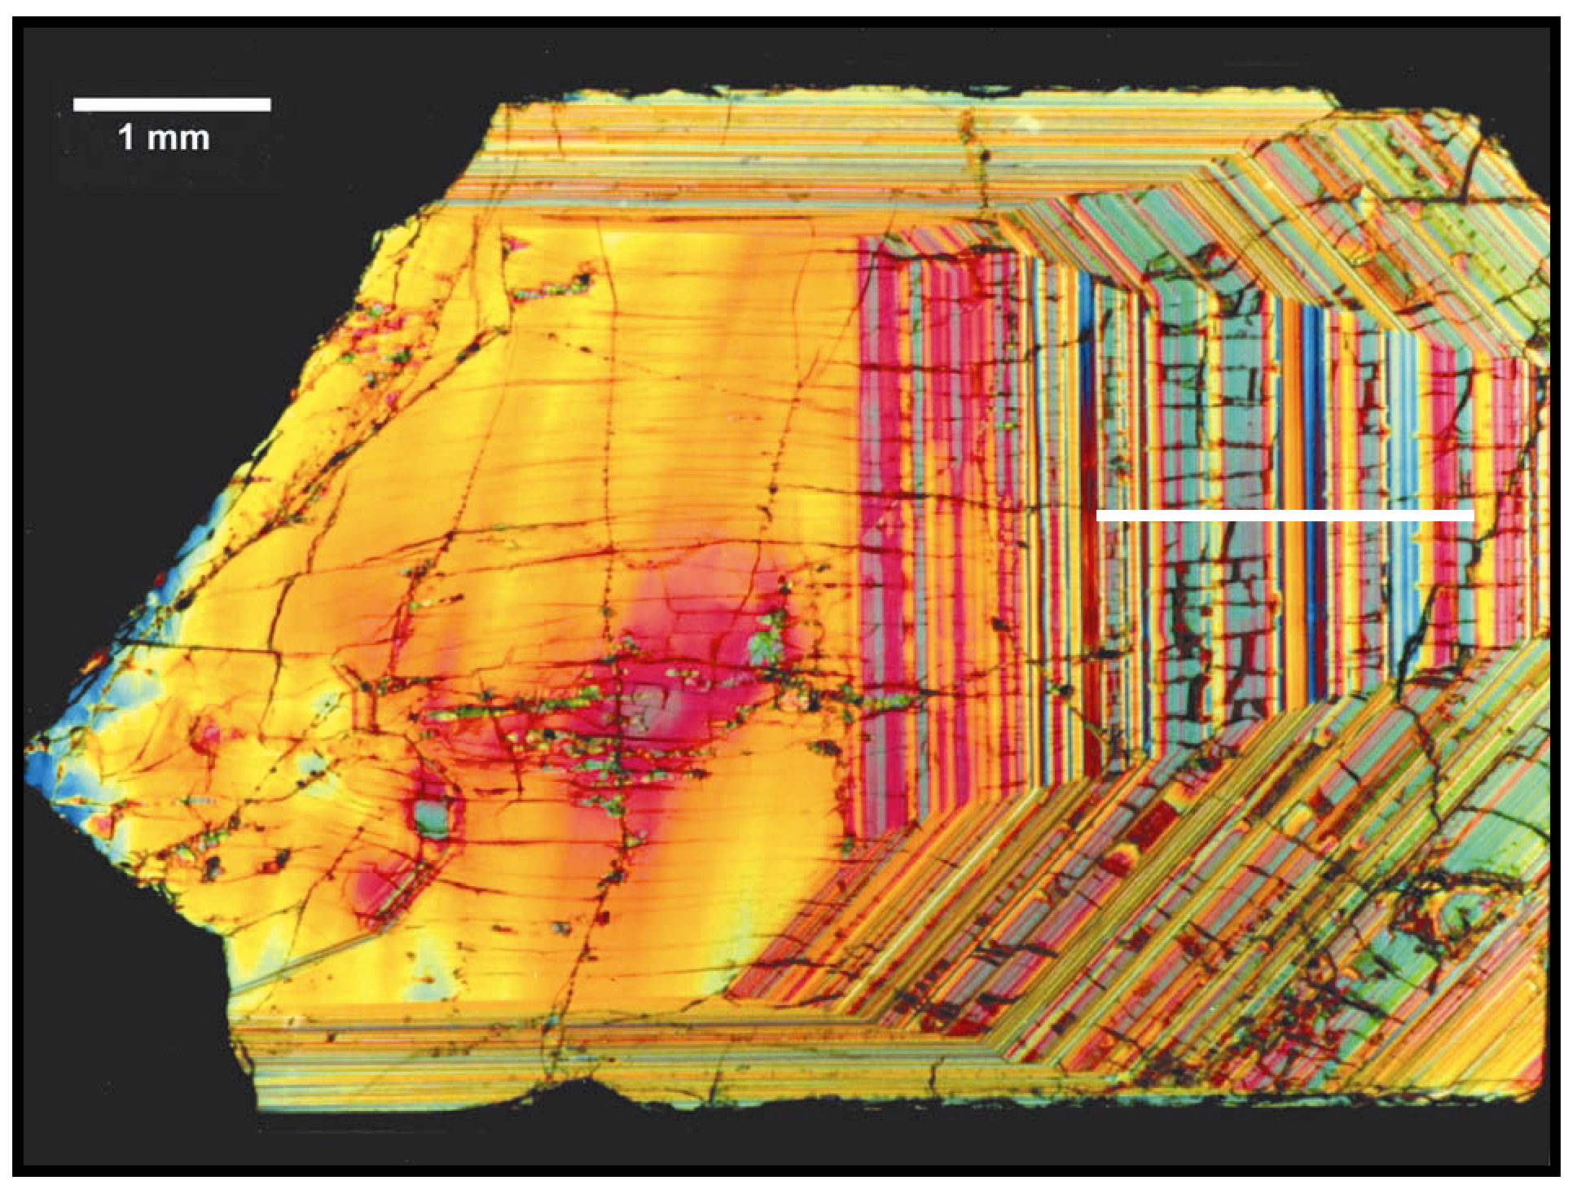
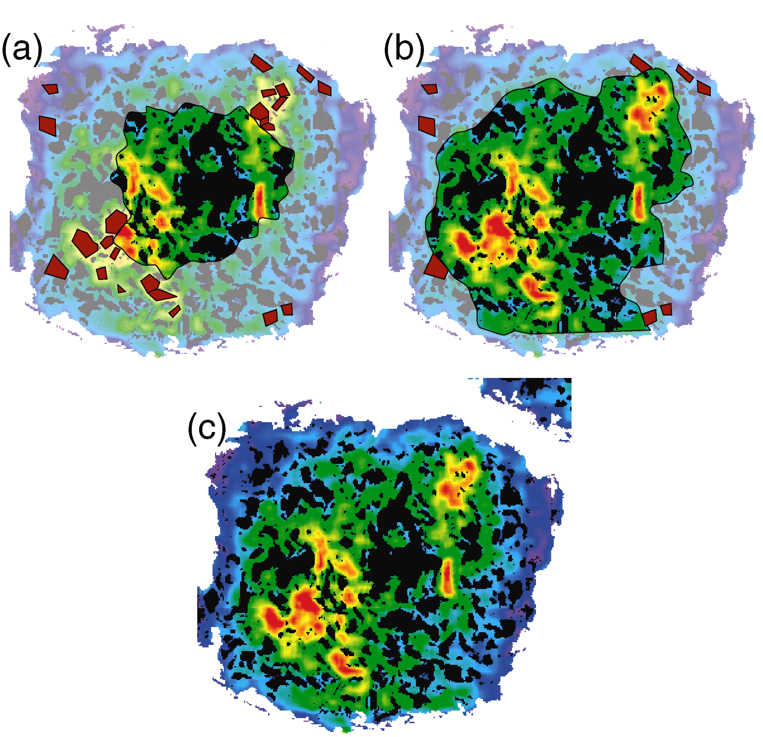
Schematic of the Mn distribution of a growing garnet (Hirsch et al., 2003). Dim region depicts garnet not yet formed.
Photomicrograph of a zoned zircon from Sri Lanka in thin section under crossed polarizers (Palenik et al., 2003).

