Special for Students of Geology, Mineralogy, Materials Science, Crystallography, Geochemistry, or Petrology
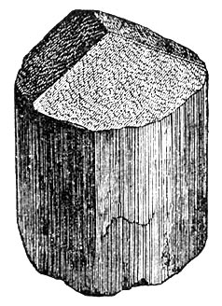

Join the

Mineralogical Society of America

Dues are only $5 a year!

Receive the American Mineralogist at the low rate of
$10 Online or Hardcopy $35/year (8 issues)

Major discounts (25%) on
Reviews of Mineralogy and Geochemistry
(52 published so far, 3-4 every year on key topics)

Recent titles include:
Stable Isotope Geochemistry (662 pp) $32→$24
Micas: Crystal Chemistry and Metamorphic Petrology (499 pp) $32 → $24
Phosphates – Geochemical, Geobiological, and Materials Importance (742 pp) $40→ $30
Nanoparticles and the Environment (349 pp) $28 → $21
Planetary Materials (1039 pp) $40 → $30

Discounts on MSA short courses and Goldschmidt conferences
Discounted registration at GSA and AGU meetings
Grants for student research in crystallography, mineralogy, and petrology
Quarterly newsletter The Lattice

Check out MSA at www.minsocam.org and download a membership application
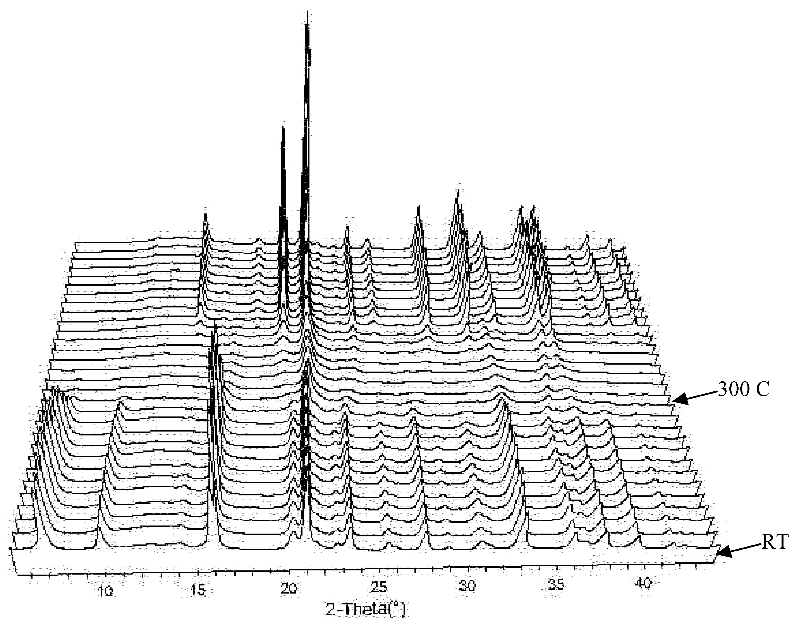
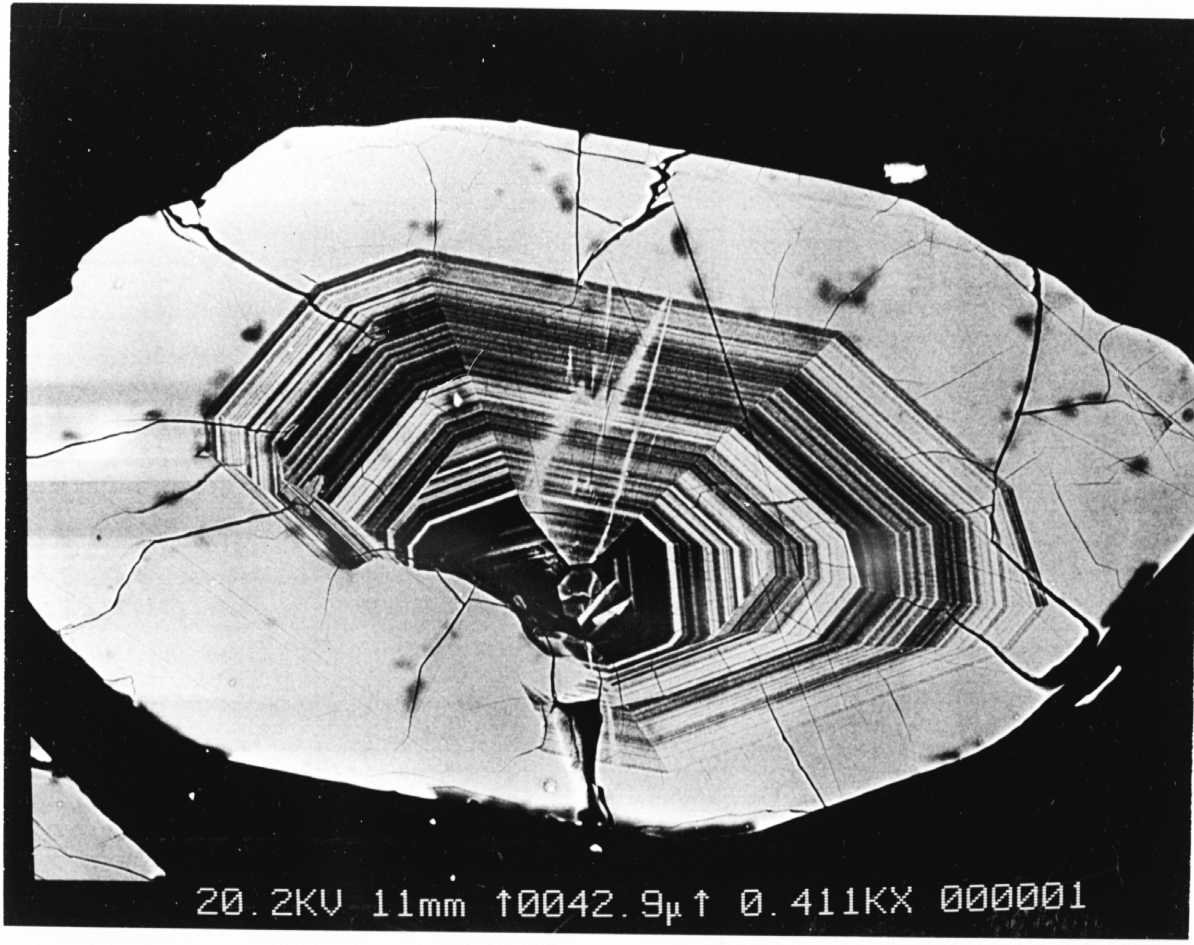
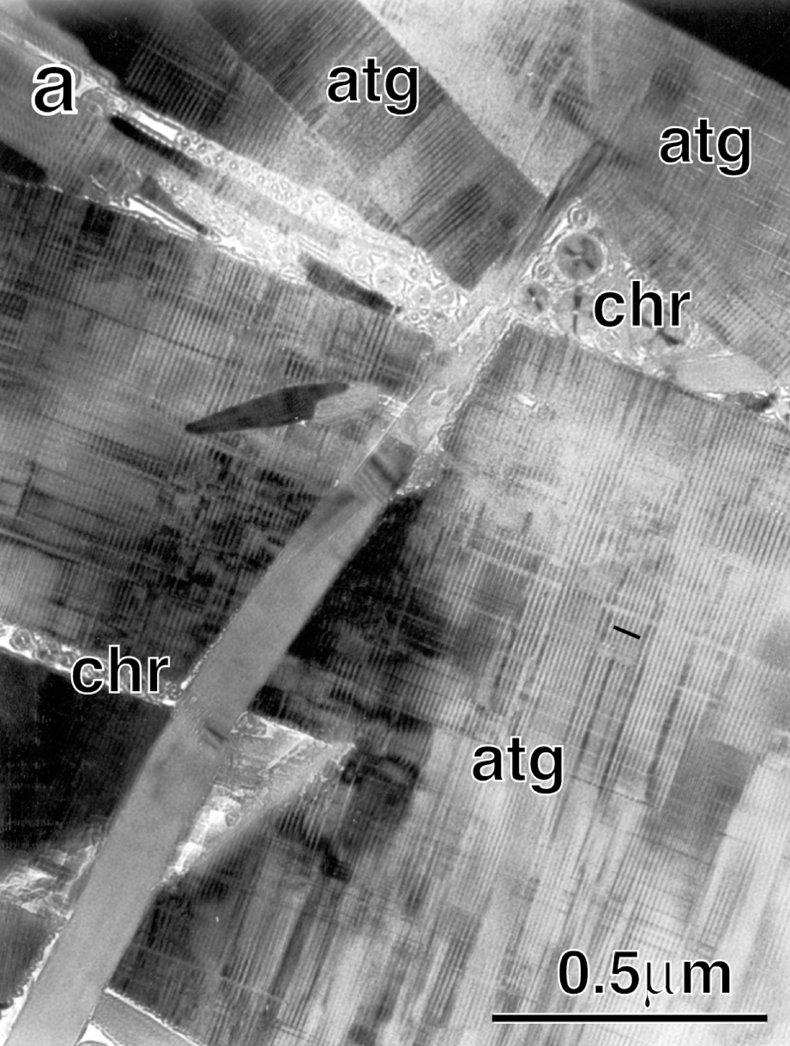
left to right: TEM image of serpentine from the Hess Deep (Pacific Ocean) (Grobéty, 2003); synchrotron x-ray diffraction pattern of the transformation of akaganeite to hematite from 26 to 800°C (Post et al., 2003); BSE image of natural zircon, North Carolina (Ayers et al., 2003).
All figures are from American Mineralogist v. 88.

