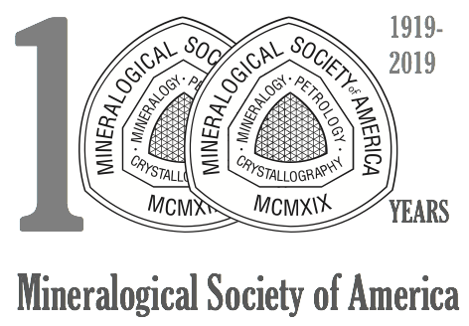
MSA Centennial Symposium

Geochemical Society
Student Fellowship
Application Form

The Geochemical Society is funding four $500 grants to undergraduate and/or graduate students to defray the costs of attending the MSA Centennial Symposium in Washington, D.C. on June 20-21, 2019. To be eligible for this award, you must already have registered for the Symposium (http://www.minsocam.org/MSA/Centennial/MSA_Centennial_Symposium.html).

Please fill in the following fields:

Your Name:
Email:
Degree Program (BA, MS, PhD):
Institution:
Department:
Academic Advisor:
Title of Thesis:

In 300 or fewer words, please answer the following question:

Which one of the symposia theme colloquia listed on the MSA Centennial website most excites you, and why?

Please email this form by April 12, 2019 to Dr. Joanne Stubbs at stubbs@cars.uchicago.edu

