Appendix 1. Tables of structural parameters
Table A1 Unit-cell parameters of z626-wadsleyite at different temperatures. Standard deviations in parentheses result from Rietveld fits.
T (K) | a(Å) | b(Å) | c(Å) | V(Å³)
297 | 5.70158(8) | 11.44275(16) | 8.24913(12) | 538.188(13)
297* | 5.70032(8) | 11.44070(16) | 8.25282(12) | 538.213(13)
343 | 5.70334(10) | 11.44579(20) | 8.25358(14) | 538.788(16)
389 | 5.70496(10) | 11.44901(20) | 8.25756(14) | 539.352(16)
437 | 5.70698(10) | 11.45336(20) | 8.26188(14) | 540.030(16)
484 | 5.70934(10) | 11.45695(21) | 8.26654(14) | 540.728(16)
532 | 5.71185(10) | 11.46233(21) | 8.27199(14) | 541.576(17)
581 | 5.71434(11) | 11.46594(21) | 8.27682(14) | 542.300(17)
629 | 5.71632(11) | 11.47040(22) | 8.28235(15) | 543.061(18)
678 | 5.71885(11) | 11.47449(22) | 8.28653(14) | 543.770(18)
728 | 5.72145(11) | 11.47888(22) | 8.29240(15) | 544.610(18)
777 | 5.72370(11) | 11.48366(22) | 8.29757(15) | 545.391(18)
827 | 5.72685(12) | 11.48883(23) | 8.30394(15) | 546.356(18)
878 | 5.72956(11) | 11.49445(23) | 8.31005(15) | 547.285(18)
929 | 5.73213(12) | 11.49976(23) | 8.31632(15) | 548.196(19)
980 | 5.73474(12) | 11.50466(23) | 8.32281(15) | 549.108(19)
1031 | 5.73699(12) | 11.50964(24) | 8.32892(16) | 549.964(19)
1084 | 5.73907(12) | 11.51340(24) | 8.33503(16) | 550.747(19)
*Lattice parameters after high-temperature diffraction

Table A2 Unit-cell parameters of z627-wadsleyite at different temperatures. Standard deviations in parentheses result from Rietveld fits.
T (K) | a(Å) | b(Å) | c(Å) | V(Å³)
297 | 5.70297(12) | 11.44477(23) | 8.24998(15) | 538.469(18)
297* | 5.6915(7) | 11.4257(14) | 8.2516(8) | 536.6(1)
320 | 5.70411(12) | 11.44737(24) | 8.25218(16) | 538.843(19)
366 | 5.70616(12) | 11.45068(24) | 8.25611(16) | 539.450(19)
413 | 5.70823(12) | 11.45481(24) | 8.26033(16) | 540.116(19)
461 | 5.71066(12) | 11.45883(24) | 8.26515(17) | 540.851(20)
508 | 5.71279(13) | 11.46315(25) | 8.27032(17) | 541.594(20)
566 | 5.71523(13) | 11.46836(26) | 8.27558(17) | 542.417(21)
605 | 5.71744(13) | 11.47217(27) | 8.27970(18) | 543.077(21)
654 | 5.71958(13) | 11.47635(25) | 8.28483(17) | 543.815(20)
703 | 5.72242(14) | 11.48111(29) | 8.29052(19) | 544.685(23)
753 | 5.72479(13) | 11.48593(25) | 8.29583(17) | 545.488(21)
802 | 5.72763(13) | 11.49106(26) | 8.30154(18) | 546.379(21)
853 | 5.73026(14) | 11.49593(27) | 8.30719(18) | 547.234(22)
903 | 5.73339(14) | 11.50173(27) | 8.31376(18) | 548.242(22)
955 | 5.73596(14) | 11.50643(28) | 8.31947(19) | 549.088(23)
1006 | 5.73790(15) | 11.51061(30) | 8.32505(20) | 549.842(24)
1058 | 5.74067(14) | 11.51626(28) | 8.33129(19) | 550.791(23)
1110§ | 5.74364(15) | 11.52211(29) | 8.33924(20) | 551.881(24)
1163§ | 5.74303(37) | 11.5213(40) | 8.34814(48) | 552.373(60)
*Lattice parameters after high-temperature diffraction up to 1163 K: sample is a mixture of wadsleyite (11%), forsterite (88%, a=4.7540(2), b=10.2127(7) Å, c=5.9845(4) Å, V=290.55(3) Å³) and periclase (1%); the decrease of volume is result of strong overlapping of diffraction peaks of wadsleyite and forsterite along with minor amount of wadsleyite and reflection broadening.
§growing up in forsterite content:
1110 K − wadsleyite (91%) + forsterite (8%, a=4.8083(5), b=10.3089(14) Å, c=6.0377(8) Å, V=299.28(7) Å³) + periclase (1%);
1163 K − wadsleyite (44%) + forsterite (55%, a=4.8026(4), b=10.3115(8) Å, c=6.0430(4) Å, V=299.26(4) Å³) + periclase (1%)

Table A3 Unit-cell parameters of forsterite at different temperatures. Standard deviations of lattice parameters (as result of le Bail fits) are in the order of 0.0001 Å for a and b, 0.0002 Å for c and 0.01 Å³ for volume.
T (K) | a(Å) | b(Å) | c(Å) | V(Å³)
299 | 4.7543 | 10.1976 | 5.9813 | 289.99
314.6 | 4.7549 | 10.1997 | 5.9824 | 290.14
335.4 | 4.7556 | 10.2022 | 5.9838 | 290.32
356.2 | 4.7564 | 10.2049 | 5.9853 | 290.51
377 | 4.7572 | 10.2076 | 5.9867 | 290.71
397.8 | 4.7581 | 10.2107 | 5.9883 | 290.93
418.6 | 4.7589 | 10.2134 | 5.9898 | 291.13
439.4 | 4.7597 | 10.2165 | 5.9913 | 291.35
460.2 | 4.7605 | 10.2195 | 5.9930 | 291.56
481 | 4.7615 | 10.2226 | 5.9945 | 291.78
501.8 | 4.7624 | 10.2256 | 5.9960 | 292.00
522.6 | 4.7633 | 10.2288 | 5.9978 | 292.23
543.4 | 4.7642 | 10.2317 | 5.9993 | 292.45
564.2 | 4.7651 | 10.2348 | 6.0009 | 292.66
585 | 4.7660 | 10.2378 | 6.0025 | 292.88
605.8 | 4.7669 | 10.2407 | 6.0041 | 293.10
626.6 | 4.7679 | 10.2438 | 6.0058 | 293.33
647.4 | 4.7689 | 10.2469 | 6.0074 | 293.56
668.2 | 4.7697 | 10.2501 | 6.0090 | 293.78
689 | 4.7707 | 10.2530 | 6.0107 | 294.01
709.8 | 4.7716 | 10.2560 | 6.0122 | 294.22
730.6 | 4.7726 | 10.2592 | 6.0140 | 294.46
751.4 | 4.7736 | 10.2623 | 6.0156 | 294.69
772.2 | 4.7744 | 10.2656 | 6.0172 | 294.92
793 | 4.7755 | 10.2687 | 6.0189 | 295.15
813.8 | 4.7765 | 10.2719 | 6.0206 | 295.39
834.6 | 4.7774 | 10.2751 | 6.0223 | 295.63
855.4 | 4.7783 | 10.2782 | 6.0239 | 295.85
876.2 | 4.7793 | 10.2815 | 6.0256 | 296.09
897 | 4.7803 | 10.2846 | 6.0273 | 296.33
917.8 | 4.7813 | 10.2880 | 6.0291 | 296.57
938.6 | 4.7823 | 10.2913 | 6.0309 | 296.81
959.4 | 4.7833 | 10.2946 | 6.0325 | 297.05
980.2 | 4.7843 | 10.2977 | 6.0341 | 297.28
1001 | 4.7853 | 10.3011 | 6.0358 | 297.53
1021.8 | 4.7863 | 10.3043 | 6.0376 | 297.77
1042.6 | 4.7872 | 10.3074 | 6.0393 | 298.00
1063.4 | 4.7882 | 10.3106 | 6.0409 | 298.24
1084.2 | 4.7893 | 10.3139 | 6.0427 | 298.49
1105 | 4.7903 | 10.3173 | 6.0444 | 298.73
1125.8 | 4.7913 | 10.3203 | 6.0461 | 298.96
1146.6 | 4.7923 | 10.3236 | 6.0478 | 299.21
1167.4 | 4.7933 | 10.3267 | 6.0494 | 299.44
1188.2 | 4.7943 | 10.3299 | 6.0512 | 299.68
1209 | 4.7953 | 10.3330 | 6.0529 | 299.92
1229.8 | 4.7963 | 10.3364 | 6.0546 | 300.16
1250.6 | 4.7973 | 10.3396 | 6.0563 | 300.41
1271.4 | 4.7983 | 10.3426 | 6.0579 | 300.63
1292.2 | 4.7993 | 10.3459 | 6.0596 | 300.88
1313 | 4.8003 | 10.3490 | 6.0614 | 301.12

Table A4 Structural parameters of wadsleyite (for pure z626) at selected temperatures. Atoms are labeled as in reference (Jacobsen et al. 2005) and figure 1. Occupancies were fixed corresponding to the ideal stoichiometry; overall isotropic displacement factor was used for description of atomic displacement parameters.

T (K) | 297 |  | 728 | 929 | 1084
Symmetry | Imma |  | Imma | Imma | Imma
a (Å) | 5.70158(8) |  | 5.72145(11) | 5.73213(12) | 5.73907(12)
b (Å) | 11.44275(16) |  | 11.47888(22) | 11.49976(23) | 11.51340(24)
c (Å) | 8.24913(12) |  | 8.29240(15) | 8.31632(15) | 8.33503(16)
V (Å³) | 538.188(13) |  | 544.610(18) | 548.196(19) | 550.747(19)
 | Mg1 at 4a
x/a | 0 |  | 0 | 0 | 0
y/b | 0 |  | 0 | 0 | 0
z/c | 0 |  | 0 | 0 | 0
 | Mg2 at 4e
x/a | 0 |  | 0 | 0 | 0
y/b | ¼ |  | ¼ | ¼ | ¼
z/c | 0.9726(4) |  | 0.9711(5) | 0.9697(5) | 0.96705(5)
 | Mg3 at 8g
x/a | ¼ |  | ¼ | ¼ | ¼
y/b | 0.1286(4) |  | 0.1280(4) | 0.1301(5) | 0.1286(5)
z/c | ¼ |  | ¼ | ¼ | ¼
 | Si at 8h
x/a | 0 |  | 0 | 0 | 0
y/b | 0.1187(3) |  | 0.1196(3) | 0.1188(3) | 0.1203(3)
z/c | 0.6175(4) |  | 0.6175(4) | 0.6163(4) | 0.6168(4)
 | O1 at 4e
x/a | 0 |  | 0 | 0 | 0
y/b | ¼ |  | ¼ | ¼ | ¼
z/c | 0.2177(9) |  | 0.2148(9) | 0.2164(9) | 0.2152(9)
 | O2 at 4e
x/a | 0 |  | 0 | 0 | 0
y/b | ¼ |  | ¼ | ¼ | ¼
z/c | 0.7179(9) |  | 0.7195(9) | 0.7146(10) | 0.7154(10)
 | O3 at 8h
x/a | 0 |  | 0 | 0 | 0
y/b | 0.9929(4) |  | 0.9915(4) | 0.9907(4) | 0.9912(4)
z/c | 0.2548(9) |  | 0.2561(9) | 0.2538(10) | 0.2551(10)
 | O4 at 16j
x/a | 0.2624(5) |  | 0.2631(5) | 0.2639(5) | 0.2657(5)
y/b | 0.1227(12) |  | 0.1226(14) | 0.1235(13) | 0.1256(15)
z/c | 0.9945(4) |  | 0.9942(4) | 0.9939(5) | 0.9939(4)
B_{ov} (Å²) | 0.12(4) |  | 0.23(3) | 0.41(4) | 0.39(4)
Number of "independent" reflections* | 396 |  | 401 | 402 | 405
Effective number (account for resolution) of reflections with p=0.5* | 183 |  | 173 | 178 | 170
R_{Bragg} (%), R_{F} (%), χ2 | 4.7, 6, 9.9 |  | 4.8, 6.1, 10.4 | 4.9, 6.4, 10.8 | 4.7, 6, 10.2
*– see FullProf manual for exact meaning of these parameters.

Appendix 2. Graphical representations of results of Rietveld refinements or Le bail fits for selected diffraction patterns.
Figure A.2.1. Results of Rietveld refinements of wadsleyite (orthorhombic, space group Imma) samples. Experimental data (grey circles) and the calculated profile (solid line through the circles) are presented together with the calculated Bragg positions (vertical ticks) and the difference curve (solid line below). z626 is pure sample (a), whereas traces of forsterite (orthorhombic, space group Pbnm, displayed by black arrows) and periclase (cubic, space group Fm$\overline{3}$m, grey arrow) are visible in the diffraction pattern of z627 (b). Upper, middle and lower rows of vertical ticks in diffraction pattern of z627 correspond to calculated Bragg positions of wadsleyite, forsterite and periclase, respectively.
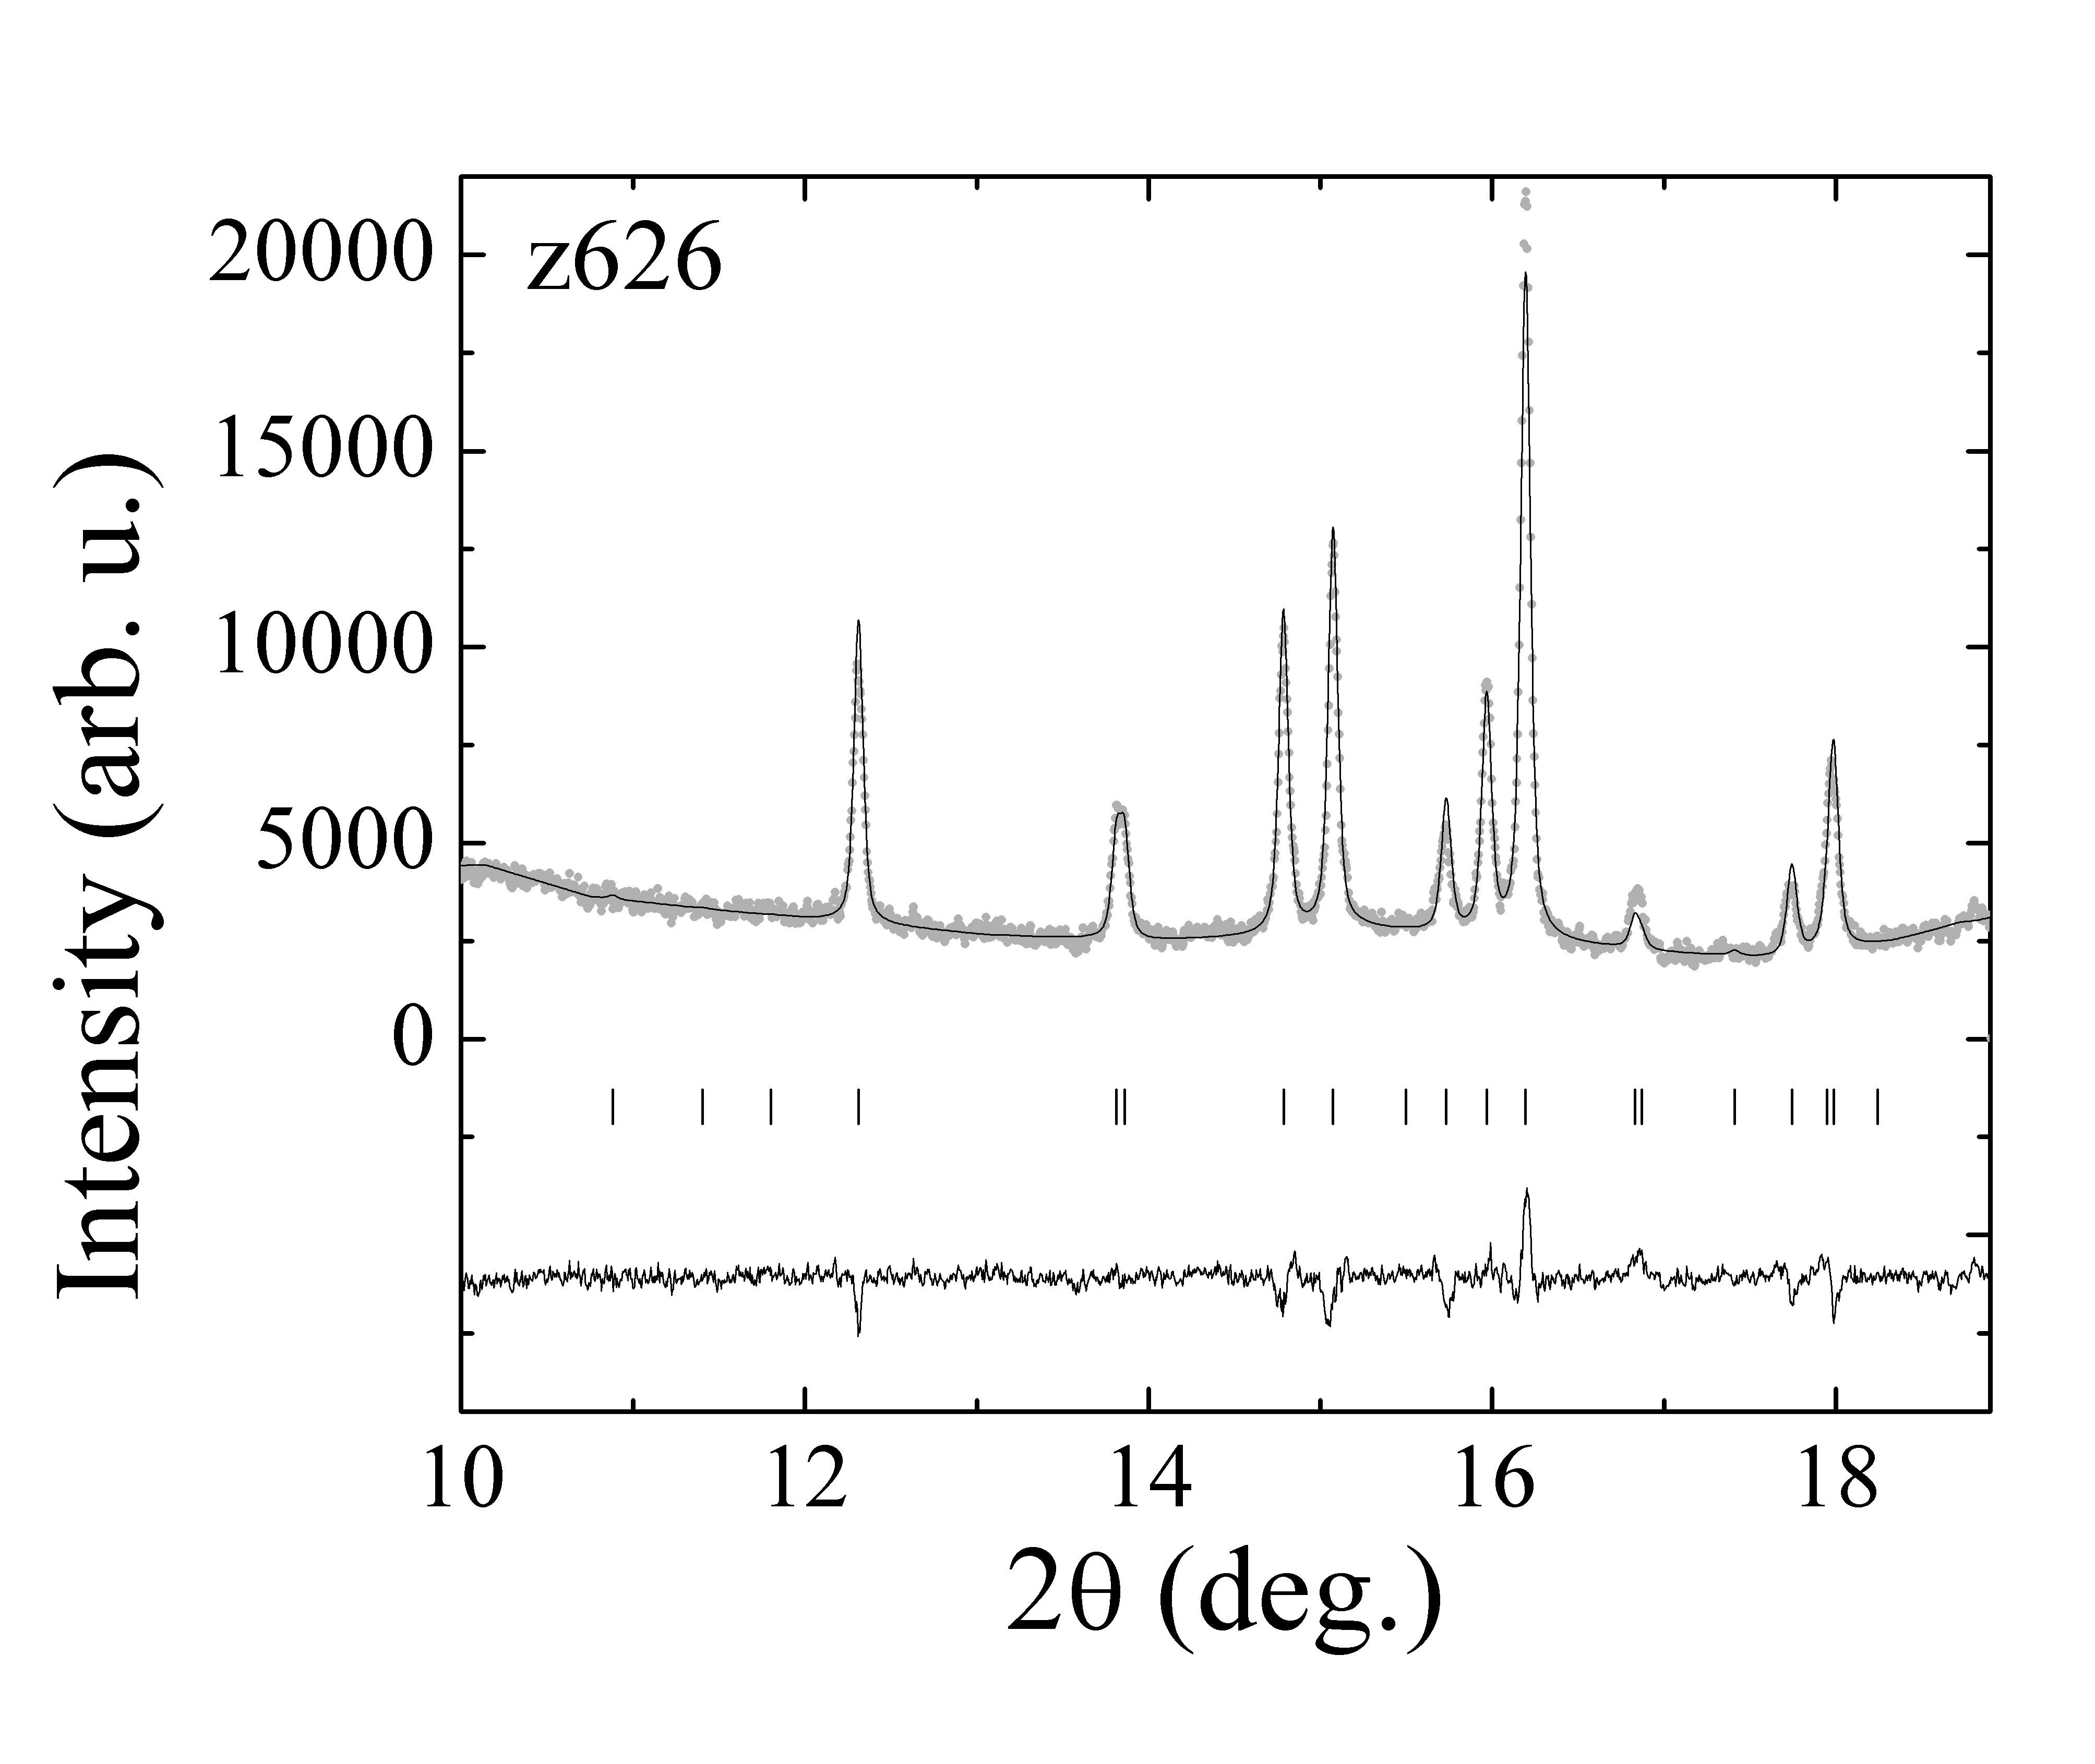

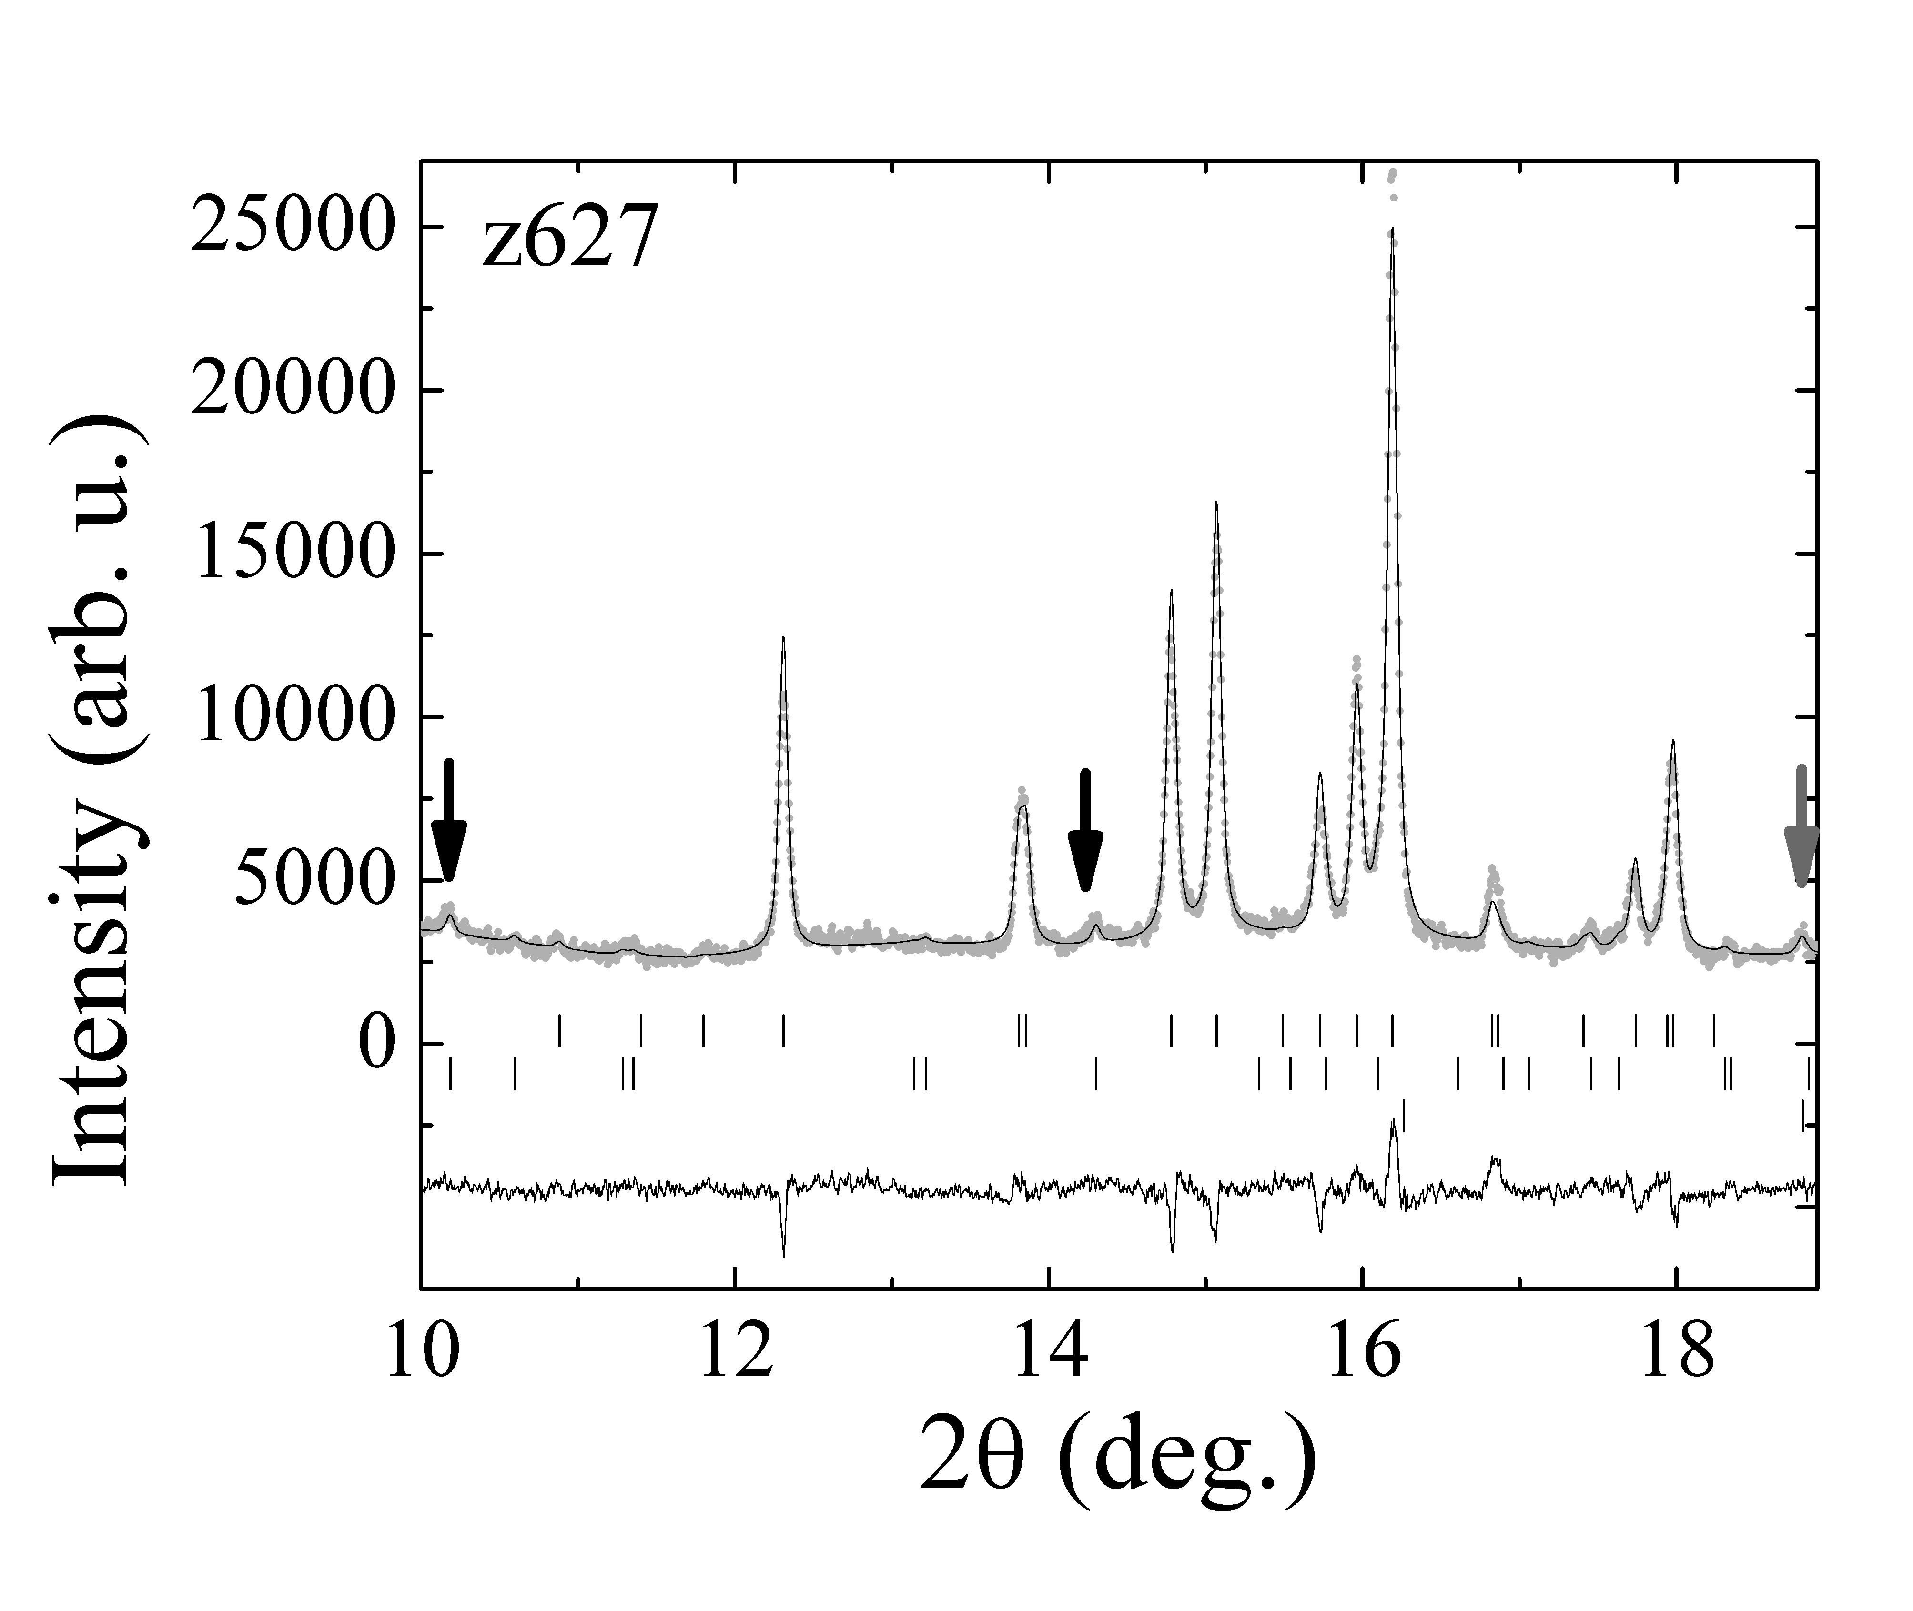

Figure A.2.2. (a–c) – results of Rietveld refinements of z627 at room temperature (94% wadsleyite, 1% periclase and 5% forsterite), 1163 K (44% wadsleyite, 1% periclase and 55% forsterite) and at room temperature after high temperature diffraction (11% wadsleyite, 1% periclase and 88% forsterite). (d and e) – an example of Le Bail fits for forsterite at lowest and highest experimental temperatures – upper, middle and lower rows of calculated Bragg maxima belong to forsterire, MgO and Si, respectively. Symbols as in figure A.2.1.

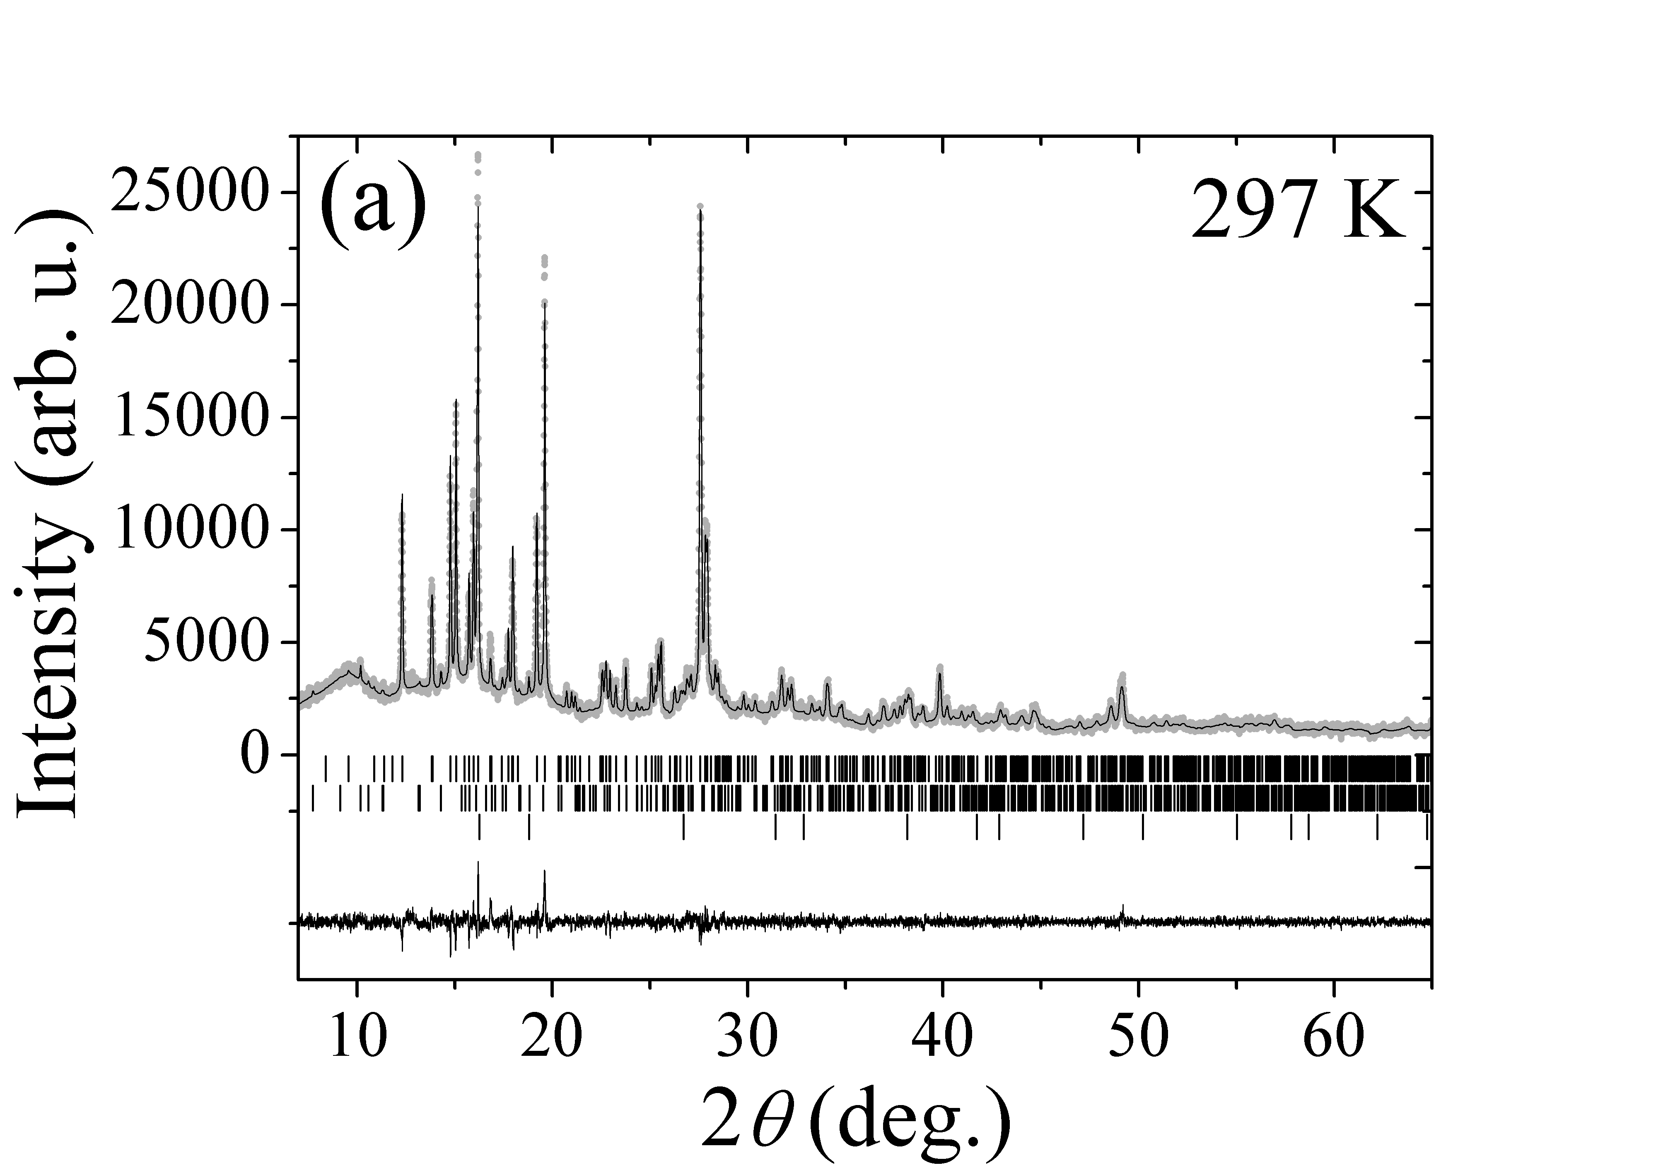
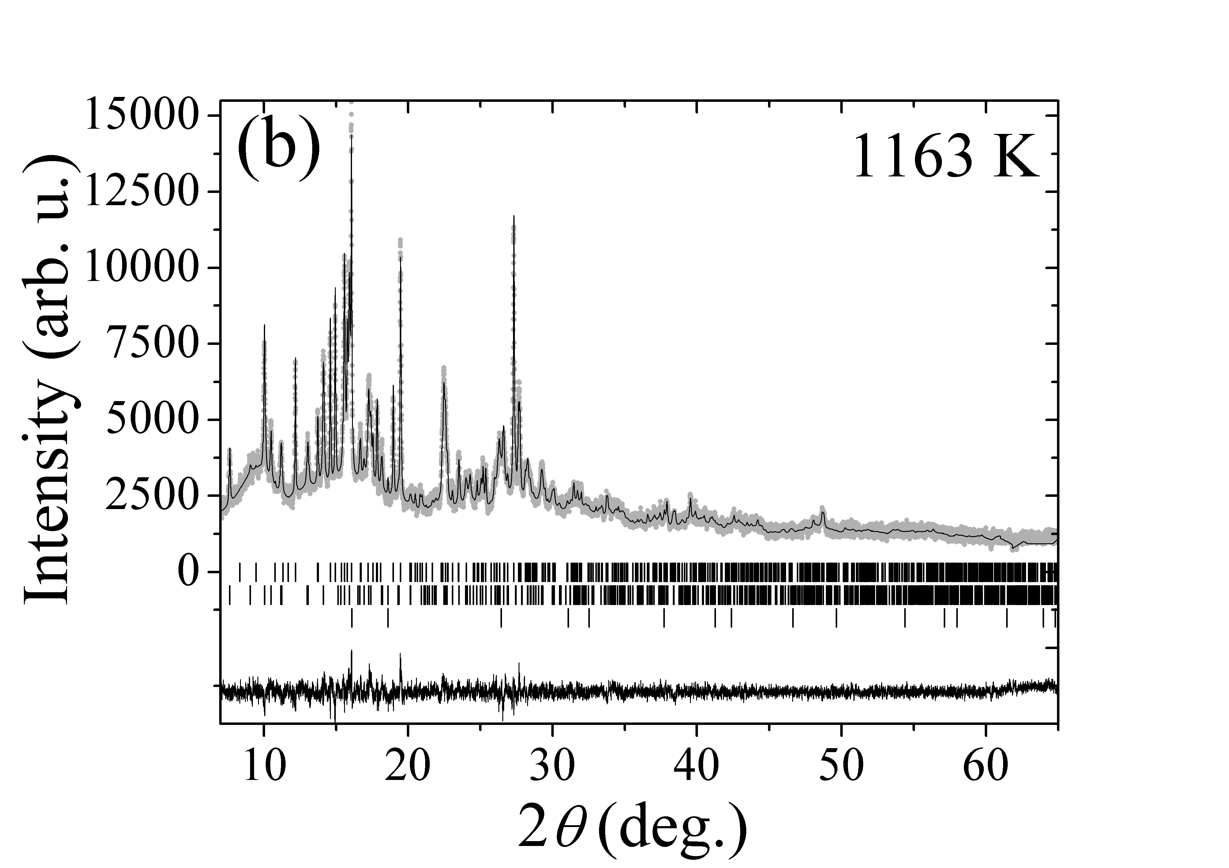

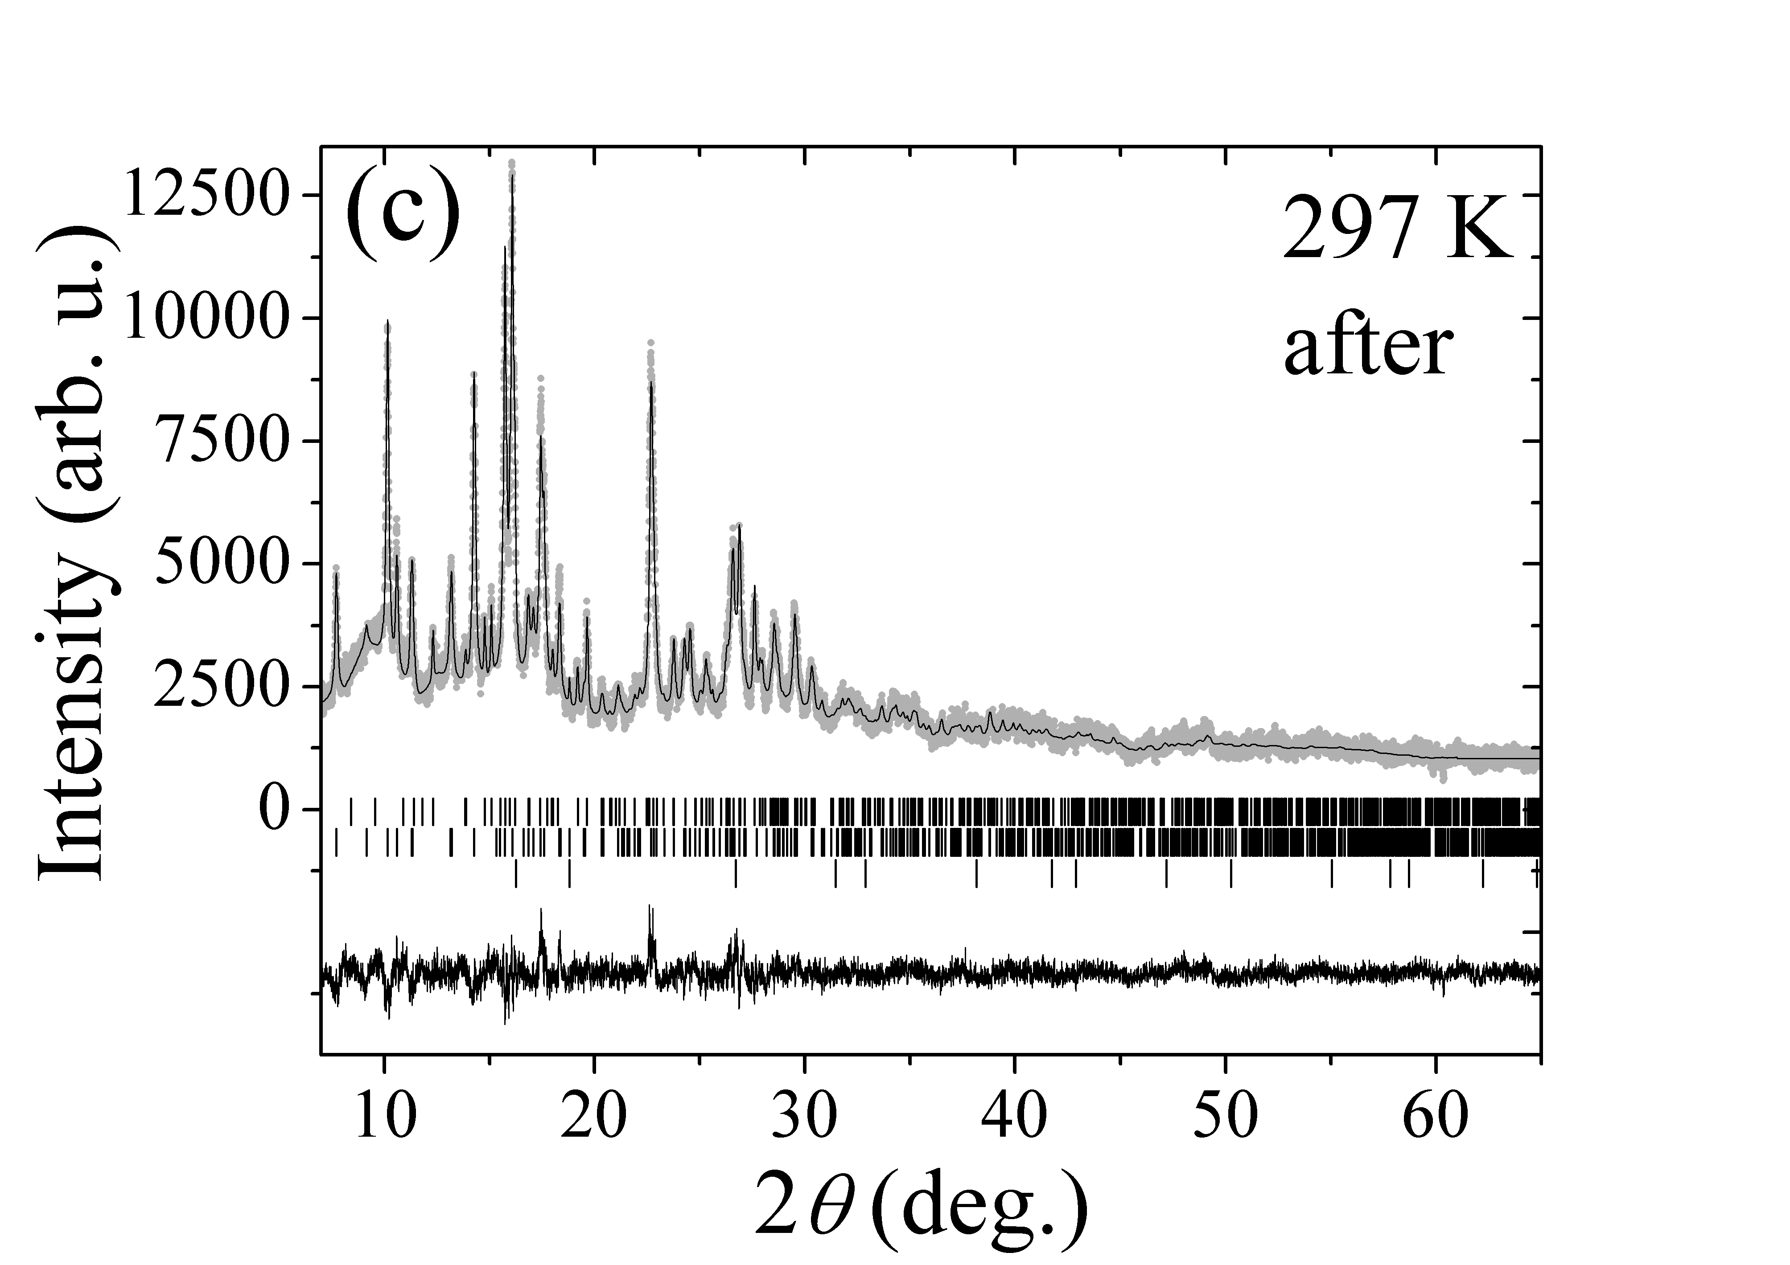

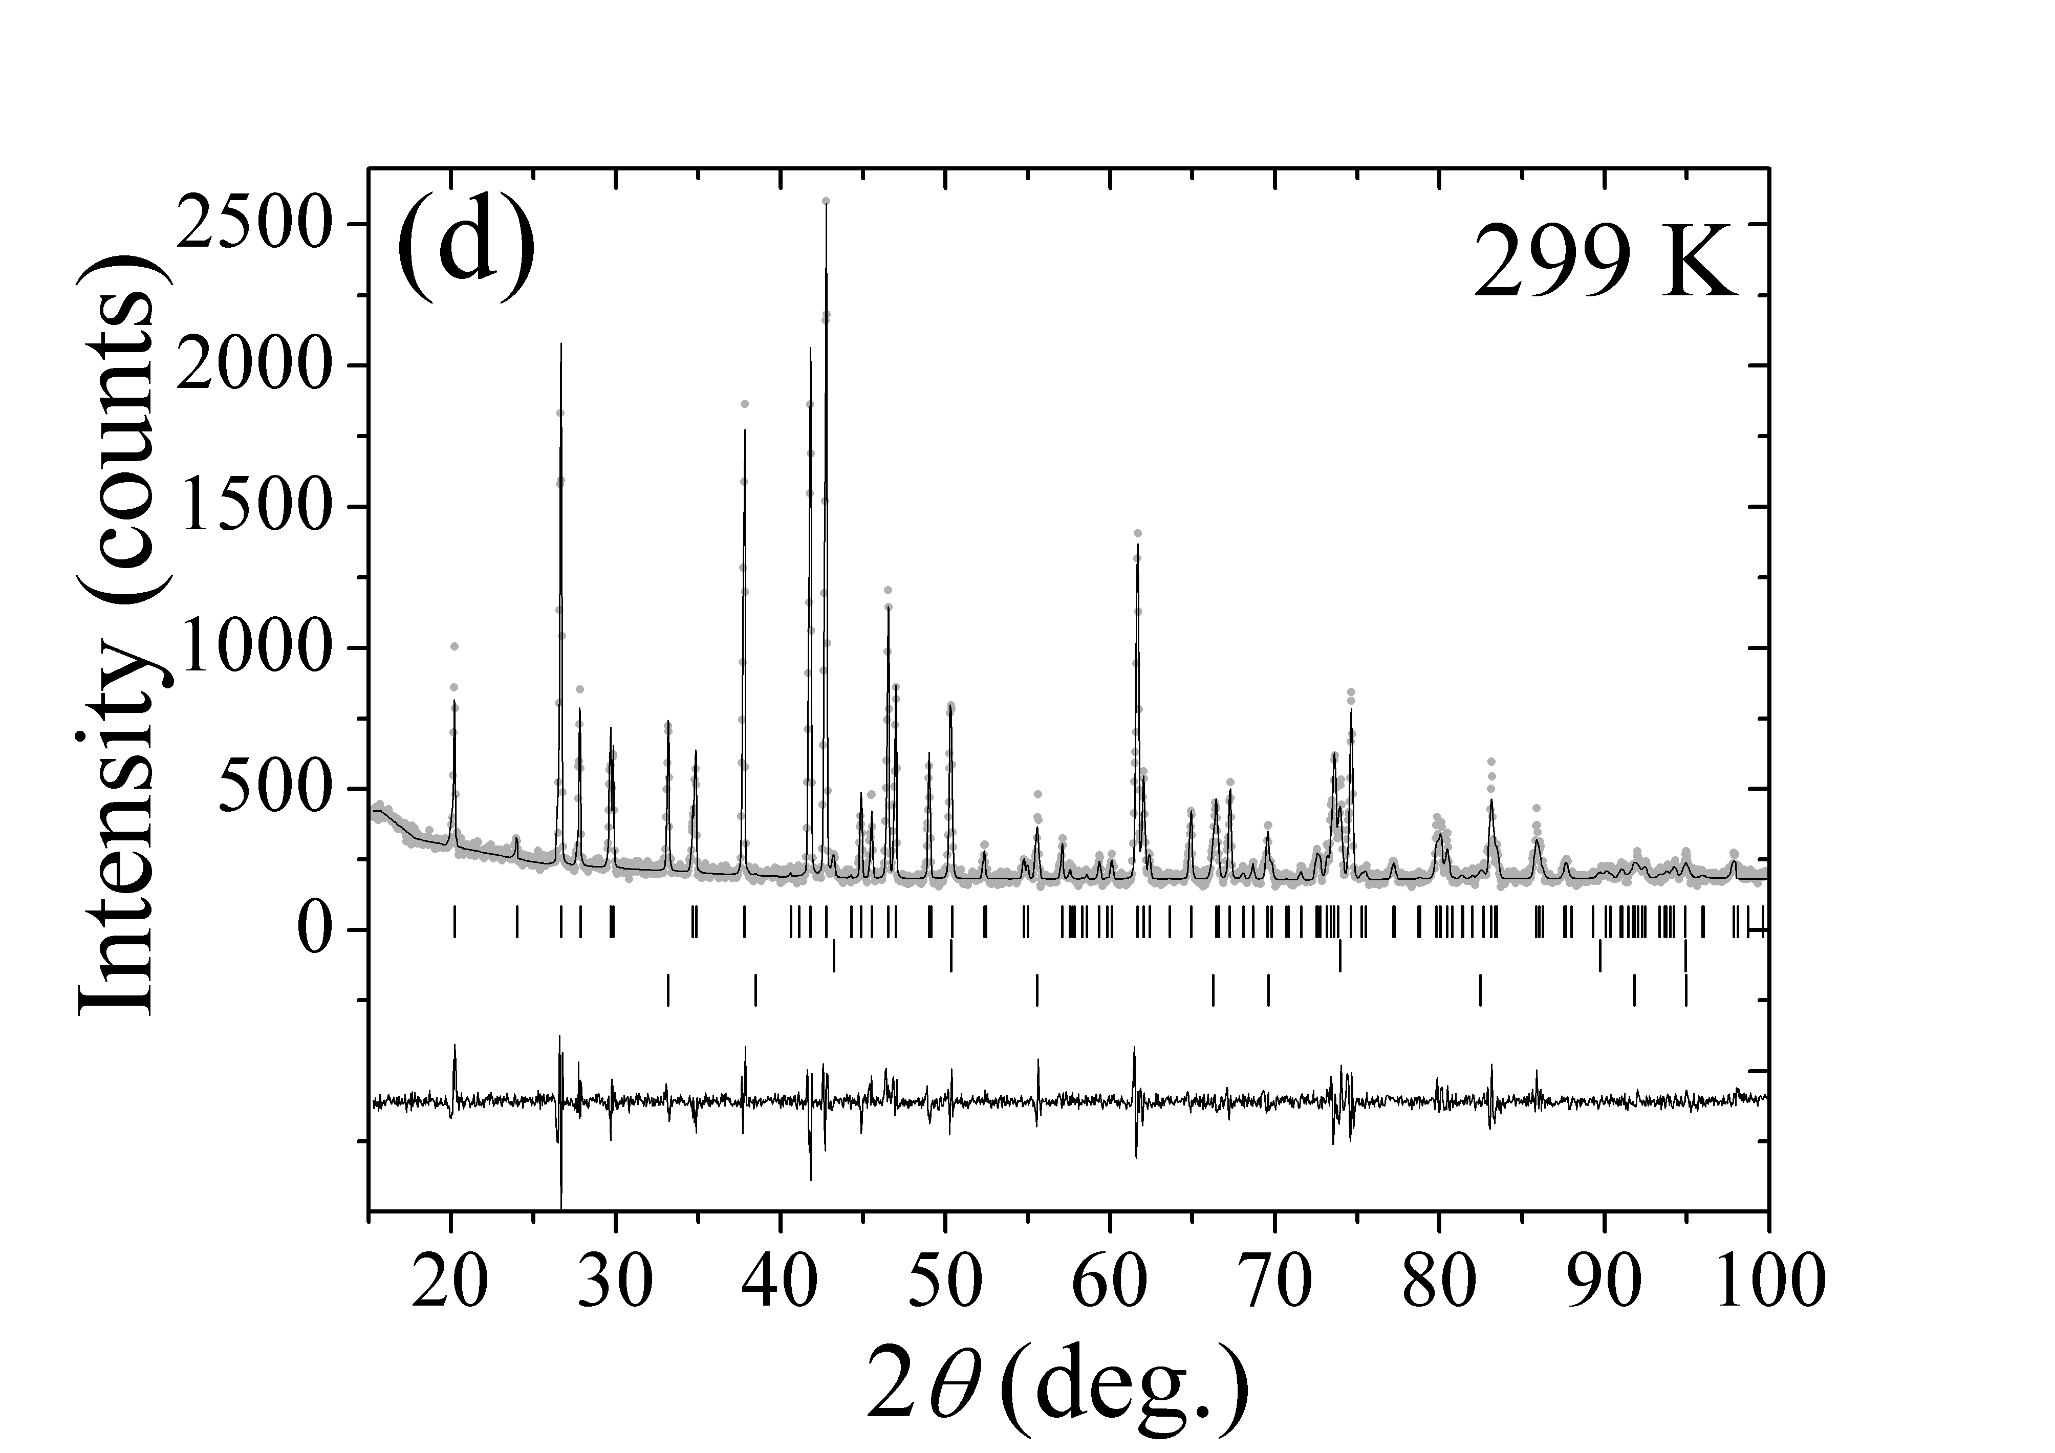

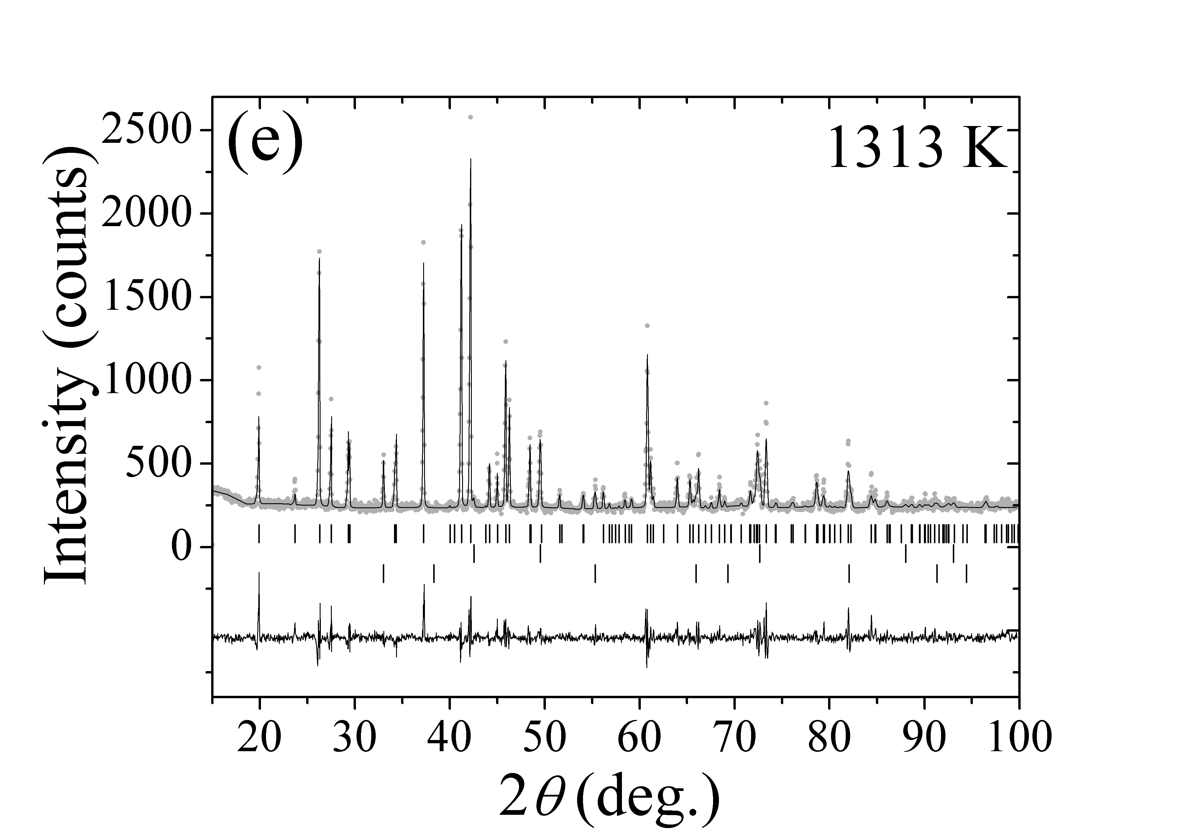

Appendix 3. Temperature dependencies of interatomic distances, angles in polyhedral volumes in wadsleyite structure.
Figure A.3.1. Temperature dependencies of selected interatomic distances in wadsleyite structure (a–e) and temperature dependences of polyhedral volumes at selected temperatures (f). Lines in all dependencies are linear fits and are presented as guides to the eye. Black and grey symbols display distances for z626 and z627, respectively.
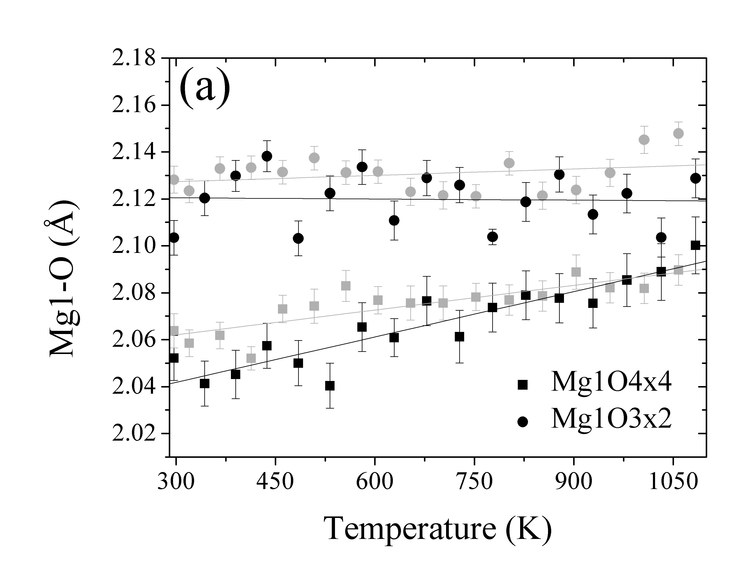

z
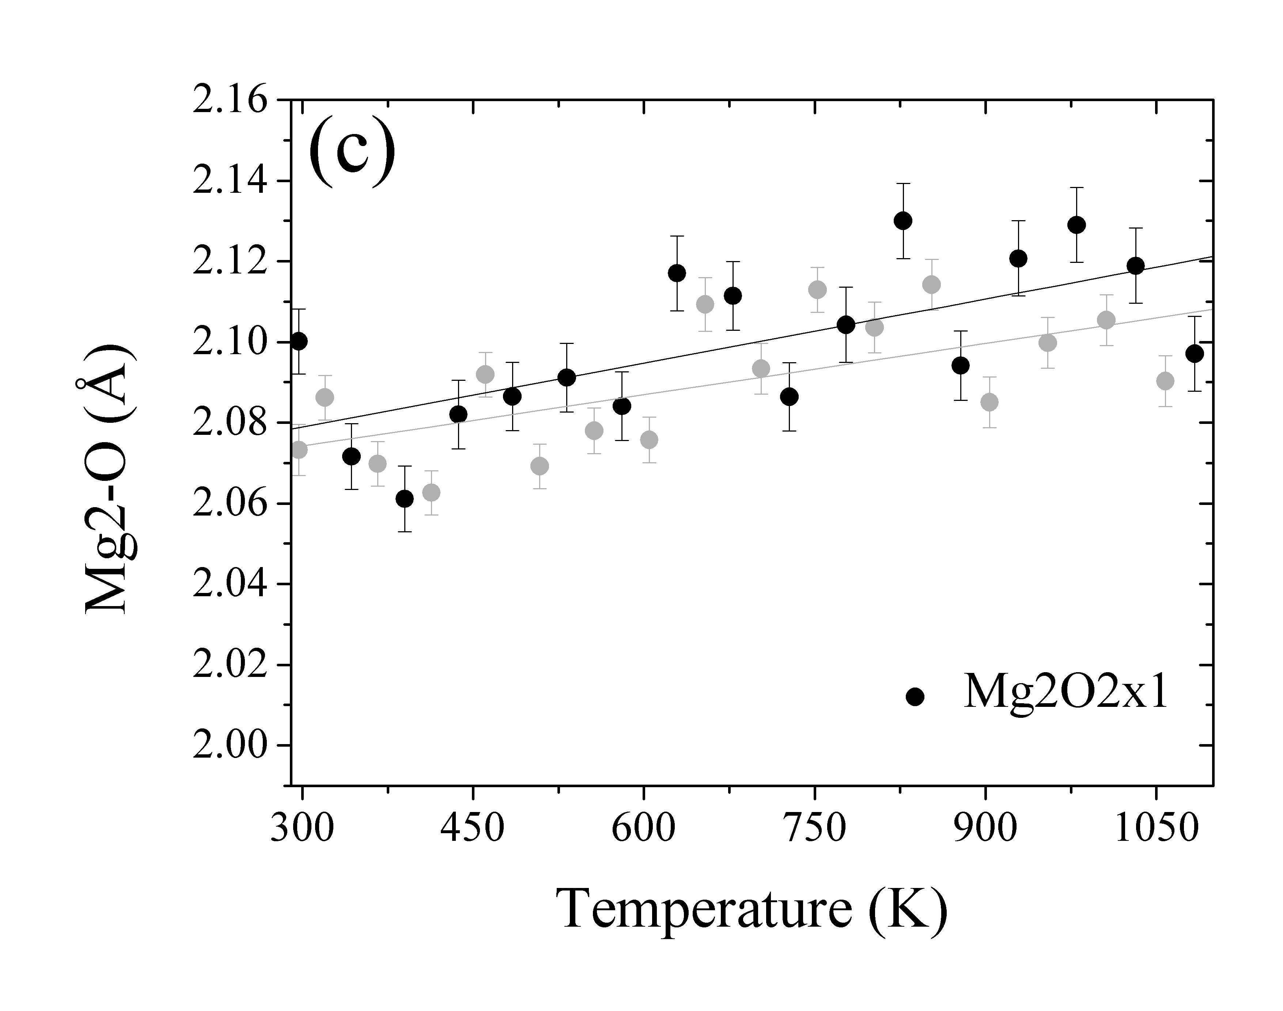

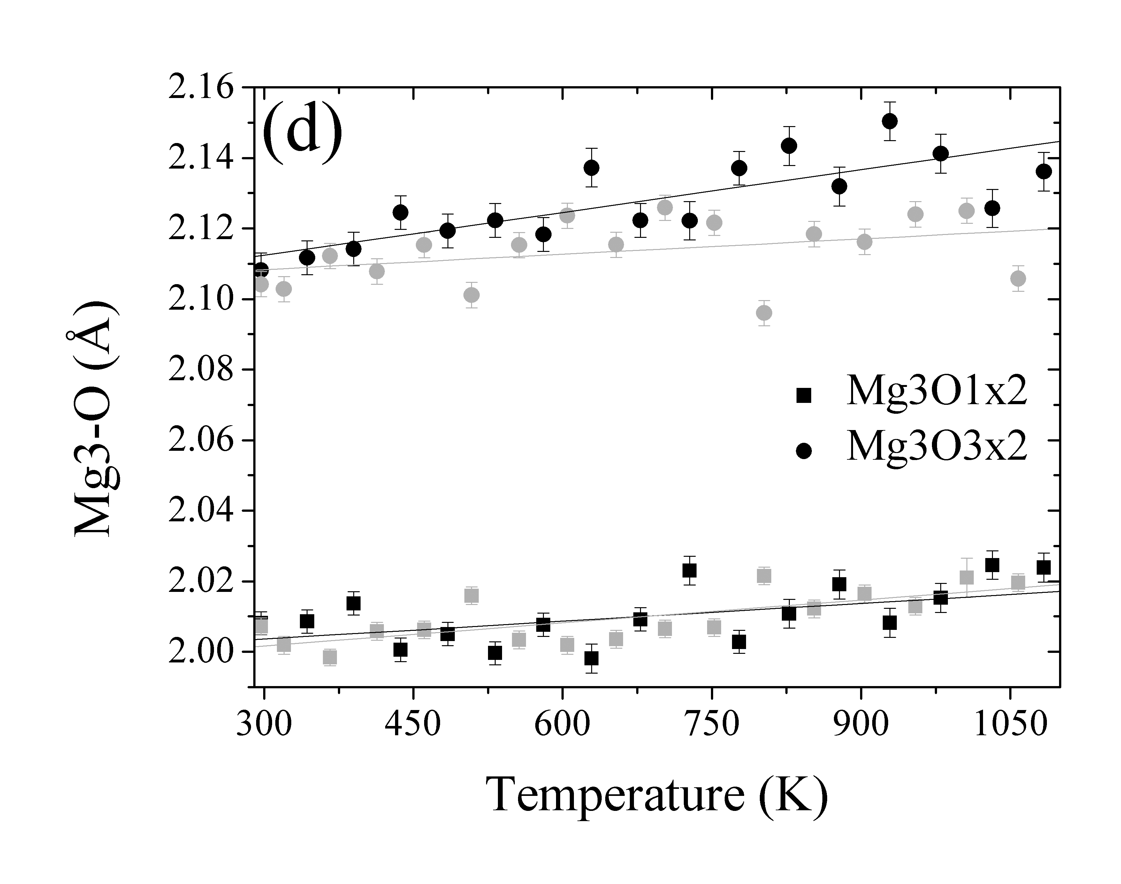
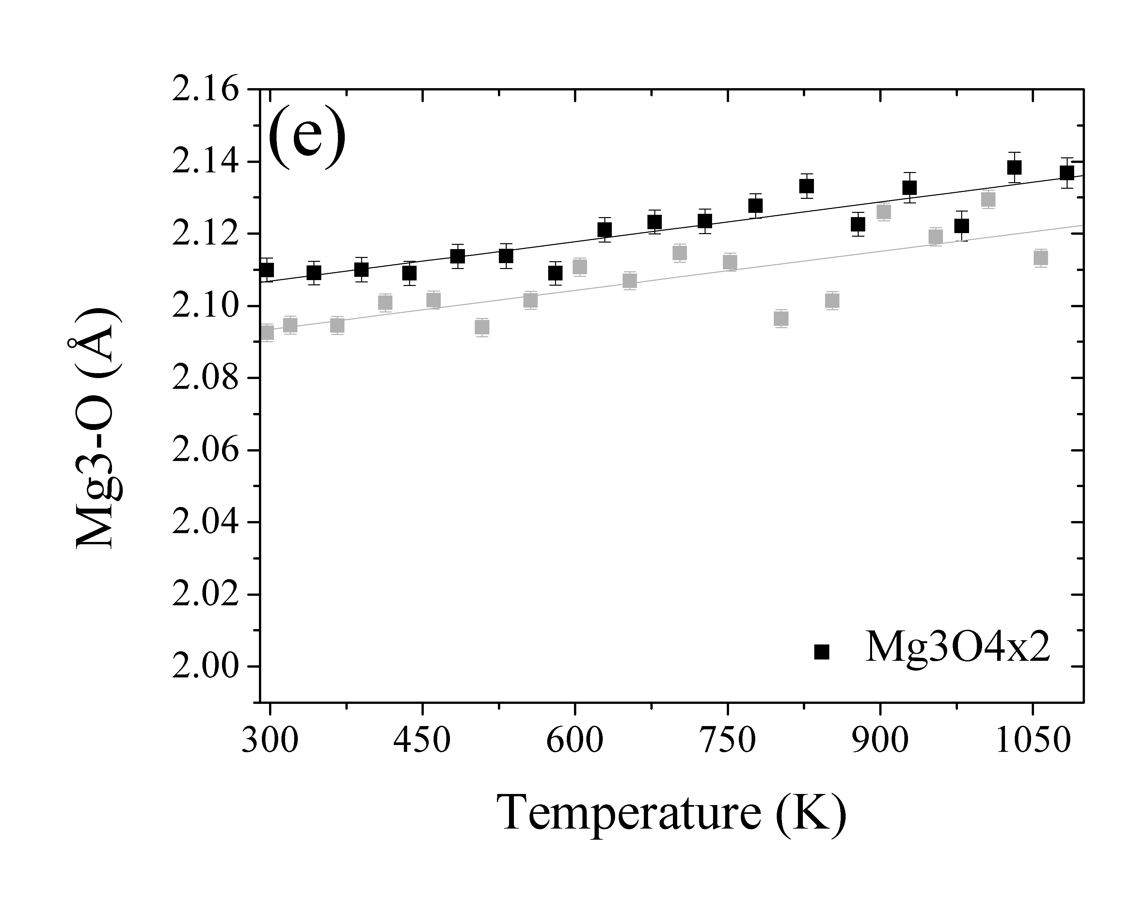

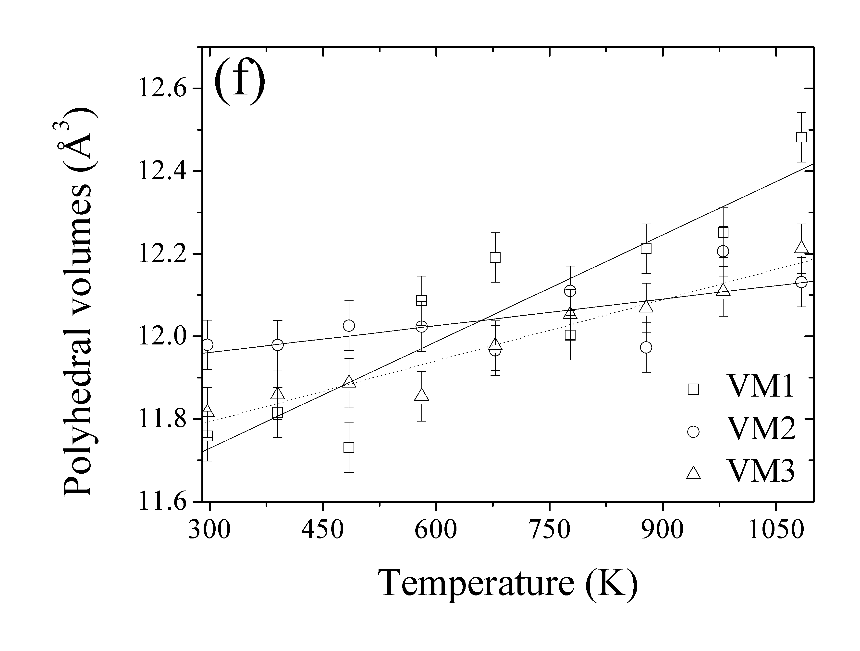

Figure A.3.2. Temperature dependencies of selected angles in wadsleyite structure. Lines in all dependencies are linear fits and are presented as guides to the eye. Black and grey symbols display angles for z626 and z627, respectively.
