Appendix B: MSCG Program introduction

The source code MSCG for the simulation program was written using a GNU Emacs 20.7.1 compiler provided free of charge by the Mathematics Department at Cambridge University (http://www.math.cam.ac.uk/catam/ccatsl). The final compiling of the source code was done using Borland C++ compiler 5.5 available free of charge from http://dn.codegear.com/. For anyone with programming knowledge and interested in modifying the program, the source code is also provided, along with comments (MSCG.cpp). This routine should run on any C++ compiler available; all the functions used can be found in stdio.h, math.h and getch.h libraries. The compiled executable file is attached electronically under the name MSCG.exe and can be run on any PC by clicking on it.
The program requires a set of data to be introduced, namely S’ (number of short Bi_{2k}X₃ modules), L’ (number of long Bi_{2(k+1)}X₃ modules) and k≥1 (X=Te, Se, S) for the sequence under consideration. It automatically assumes that the sequence is composed only from consecutive modules with 2k+3 and 2k+5 number of layers. The program is designed to recognize if the introduced S’ and L’ are coprime numbers. If they are not, the program simplifies them using a Euclidean algorithm for finding the largest common divisor. The program uses S’ and L’ to calculate the total number of layer in the stacking sequence N=S’(2k+3)+L’(2k+5) and is set for N≤1000.
The main subroutine in the program starts with an initial assumption N_{b}=2k+3, where N_{b} is for the number of layers in the basic structure. The program first verifies if it satisfies the minimal shift condition. If it does, then the corresponding basic structure is considered a valid solution and N_{b} is displayed. Afterwards a list of reflections with intensities greater than a value introduced by the user at the beginning of the program (default is 0.09) is displayed along with their position index (n_{r}). The default threshold value for the intensity chosen here (0.09) fits well the observations for phases in the tetradymite group. The program then increments N_{b} by 1 and repeats the routine above until N_{b}>N+2. This limit was chosen since structures with either S’=1 or L’=1 can have, as their basic structures, either N_{b}=N-2 or N_{b}=N+2.
The intensity of each of the reflections was calculated as a sum of all the contributions from each of the basic structure positions in the considered d₁* interval between two main reflections. Given an index n_{r} for a reflection in the derived structure, and an index t for a reflection in the basic structure, the intensity contribution will be given by the formula Int=(sin(πΔd)/(πΔd))², where Δd=(t/N_{b})N-n_{r} is the absolute separation (independent of scale) between the two reflections. Considering that the intensity value decreases very rapidly with Δd, it was assumed that a good approximation would be obtained ignoring contributions from neighbouring d₁* intervals. This leads sometimes to the apparent error where the intensity of the reflections at n_{r}=0 and n_{r}=N (indexes for the main reflections in the considered d₁* interval) is smaller than the intensity values for reflections inside the interval. This is due only to the approximation made above, where the intensity of main reflections does not contain the contributions from neighbouring intervals. If such contributions were taken into consideration, then the intensities of the main reflections would indeed be the largest within the entire interval under consideration. However, the purpose is to find the relative intensities of the reflections between the main reflections, so the mentioned error can be ignored.
The minimal shift condition states: the two reflections located about the middle of d₁* and separated by (S’+L’)d_{N}* must have a shift Δd=1/N_{b} (Fig. B1).
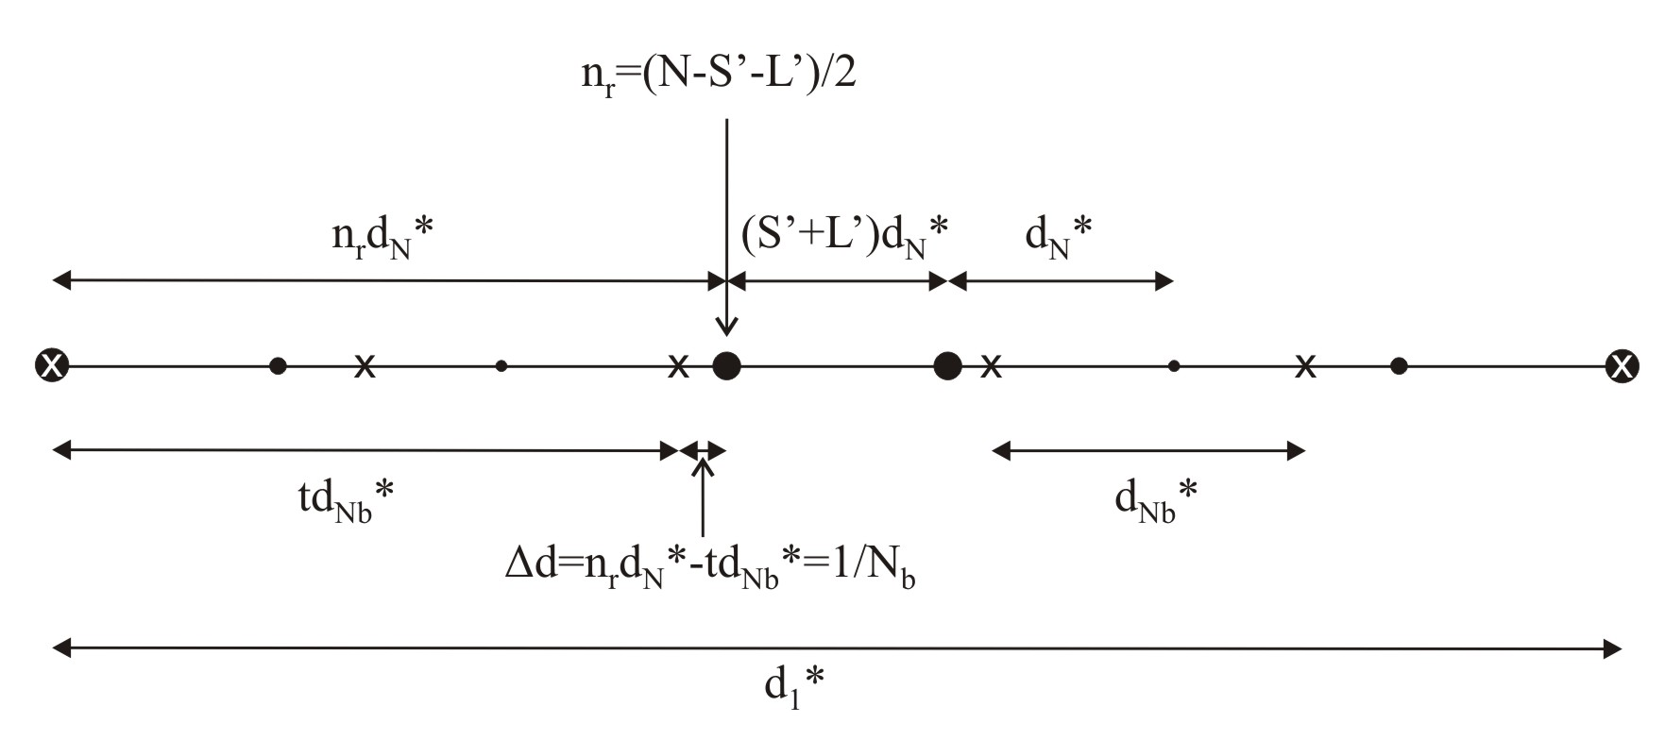
Fig. B1. Schematic representation of the minimum shift condition. Circles: reflection in derived structure;
crosses: reflections in the basic structure. Abbreviations as in text.
Thus these reflections will always have the highest intensities of all reflections within d₁*. Therefore Δd for each n_{r} and t is compared with 1/N_{b} and if they are found to be equal, then reflection n_{r} will have the highest intensity value within the d₁* interval. If the reflection where this happens is one of the reflections where the minimal shift condition applies, then the obtained value for N_{b} is listed as a solution for basic structure. The program also verifies if this Δd is repeated for any of the other reflections in the d₁* interval. If it does, then it discards that particular N_{b} as a solution for the basic structure.
The comparison between Δd and 1/N_{b} is done by subtracting the two and making a comparison with a suitable small number, our default value being 10⁻¹⁰. This is done to avoid errors that arise due to the way the program computes the values and compares them.
The program output gives two different solutions for N_{b} that add up to N. However, as discussed in the body of the paper, it is usually only the lower N_{b} that explains the observed pattern of reflections.
All output from the program is recorded in the text file “Intensities.txt” located in the parent folder of the program, i.e., if the program was being run from the desktop then the “Intensities.txt” file would appear somewhere on the desktop once the program was run for the first time. The data located in the file “Intensities.txt” must be saved to a different location once the program closes. This is because the program automatically overwrites any information located in the file “Intensities.txt”.

